Managing your Starfish Calendar
Last updated September 25, 2020

Purpose
This document provides guidance on setting up your office hours in Starfish, making appointments with students, and documenting outcomes. It is intended for staff members who will manage a calendar in Starfish to make, edit, and document student meetings.

Related Resources
For the latest FAQ and tips for using these features, please visit Starfish Help by selecting the Help link on your Starfish Home page.

Contents
Purpose 1
Related Resources 1
Important Terms 4
Establish your availability 6
Office Hours Setup Wizard 6
Office Hours (Recommended) 7
Appointment Preferences 7
My Locations 9
Add Office Hours 10
Scheduling Wizard (ideal for less structured office hours) 12
Manage Office Hours 15
Add Appointments 18
Manage Appointments 21
Scheduling 21
Outcomes 23
SpeedNotes 24
Cancel Appointments 25
Review Appointment information and meeting outcomes 26
Filter student lists based on meetings 28
Group Sessions 29
Add a Group Session 29
Edit a Group Session 32
Cancel a Group Session 33
Manage Group Session Participants 33
Add Participants 33
Remove Participants 35
Session Sharing 35
Reserve time on your calendar 36
Event 37
Manage Saved Events 40
Tips for Creating and Managing Appointments 40
Notifications 41
Email Notifications 41
Appointment Notifications 42
Tracking Items 42
Calendar Managers 43
Add Calendar Managers 44
Remove Calendar Managers 44
How Calendar Managers interact with your Starfish Calendar 44
Calendar Sync 47
External Calendar Integration 48
How Starfish Communicates with your Online Calendar 49
When the Starfish Calendar is updated 49

Important Terms
- Appointment: A documented set of details shared between a student and a calendar owner (e.g. advisor, instructor) about a planned meeting. Students may only schedule appointments in the future at times the calendar owner designates as available. Calendar owners and calendar managers can schedule future appointments and create appointments to document past meetings.

- Appointment Type: Grouping of appointment reasons and activities (i.e., SpeedNotes) that a common set of roles can add and/or view. Your Starfish administrator will create appointment types and associated reasons and SpeedNotes that will be available to you based on your role. You may be able to use appointment types to allow different groups of students to see different office hours on your calendar.

- Calendar attachment (iCal): Attachment to an emailed calendar invitation that allows a user to accept or decline from his/her email client (e.g., Outlook, Google). iCal is the industry standard to communicate meeting information between online calendaring software.

- Calendar Manager: A Starfish user who can see and edit another user’s Starfish calendar. A calendar owner can designate his/her own calendar managers by navigating to Profile > Appointment Preferences. Or, a Starfish Admin can batch upload these relationships.

- Calendar Owner: The Starfish user associated with a Starfish calendar. The calendar owner can add office hours and make appointments with students on his or her calendar. Only users with staff roles are calendar owners. Students do not own calendars in Starfish.

- Group Session: Groups sessions are like Office Hours, but more than one student can sign up for this block of time. The Calendar Owner decides how many students can sign up for each Group Session.

- Meeting: A documented occurrence of a meeting between a student and a calendar owner (e.g., advisor, instructor) that includes details about the outcomes of the meeting. Calendar owners may designate available times for walk-in meetings or restrict availability to scheduled appointments only. Students may only schedule appointments in the future at times the calendar owner designates as available. Calendar owners and calendar managers can schedule future appointments and create appointments to document past meetings.

- Office Hours: Calendar owners can add blocks of time labeled Office Hours to their calendars to indicate when they are available to meet with students. Calendar owners or calendar managers can add appointments outside the blocks, but students can only self-schedule within the block. Office Hours allow students to sign up for individual one-on-one slots within the time parameters entered by the calendar owner.

- Outcomes: Results of a meeting documented on the Outcomes tab of an Appointment in Starfish.

- SpeedNotes: Activity codes that provide an easy way for staff to document common outcomes of an appointment. Specific SpeedNotes are set up by the institution per Appointment Type.

Establish your availability
Students can only schedule an appointment at times you indicate are available by adding office hours or group sessions. There are three ways you can add office hours: use the Office Hours Setup Wizard for quick initial setup, use the Add Office Hours button (recommended) to add additional blocks at any time, or use the Scheduling Wizard to setup multiple office hour blocks that don’t follow a consistent recurrence.

Office Hours Setup Wizard
The first time you log in to Starfish the Office Hours Setup Wizard will display if you have a role that can be a calendar owner. Use the Office Hours Setup Wizard to quickly create appointment availability.

- Complete the fields presented to specify:
  - What day(s) do you have office hours? - check the boxes for each day

  - What time are your office hours? - enter a start and end time

  - Where are they? - select the Type of setting and enter the Details in the field provided (e.g. the building and room number of your office).

  - If relevant, provide Instructions for students who make appointments with you.

- Select Set up Office Hours to save your settings.
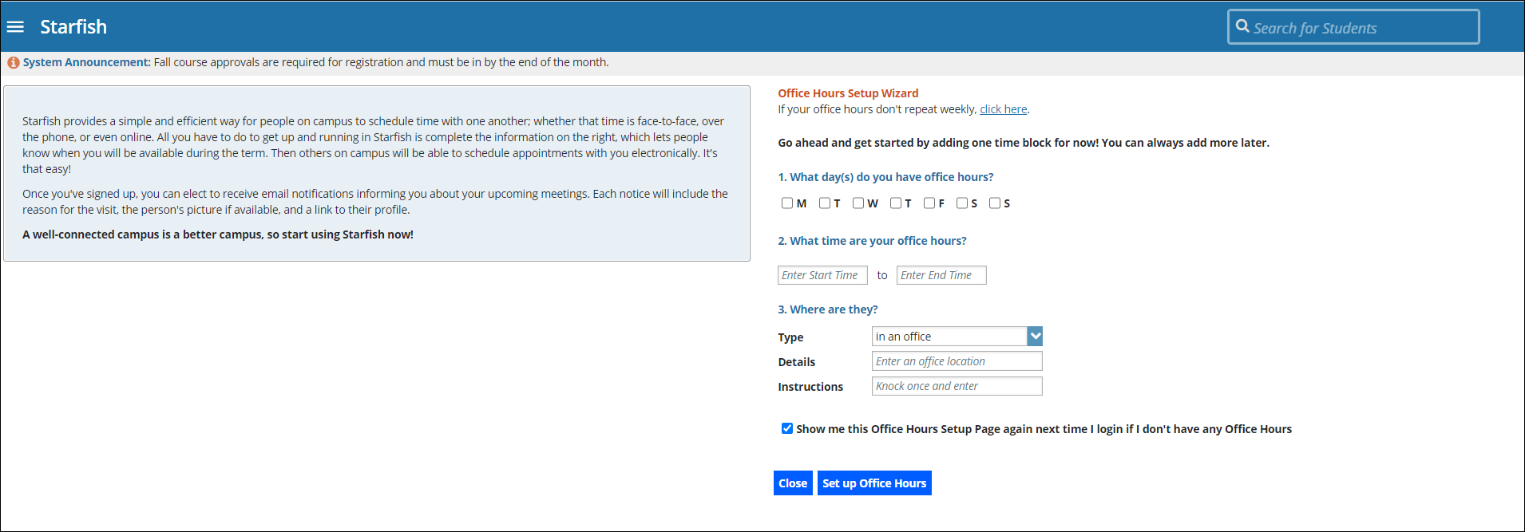

A confirmation message will display.

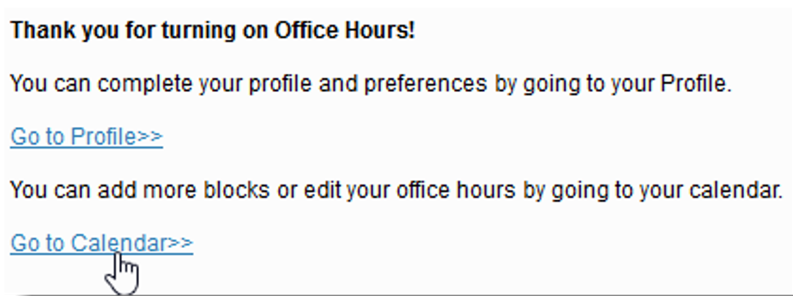

If you choose not to complete the wizard now, but want to use it later, check the box labeled Show me this Office Hours Setup Page again and then select the Close button.

Office Hours (Recommended)
The Add Office Hours option is designed for setting up a recurring block of time on a regular pattern such as weekly or daily at a certain time. If you want to set up a group of Office Hours that are less structured, use the Scheduling Wizard (discussed next).

Appointment Preferences
Before you begin to set up your office hours in this manner, it is a good idea to establish your Appointment Preferences and your Locations first.
- Navigate to the hamburger menu > Your Name > Appointment Preferences.
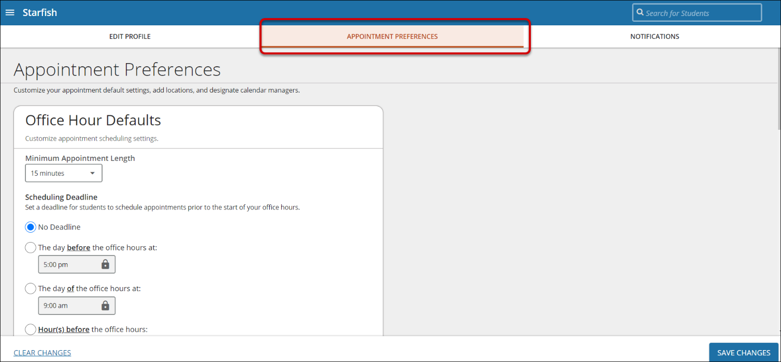

Office Hour Defaults
The Office Hour Defaults section allows you to manage your office hour blocks. You can change these whenever you add a block of office hours.
- Select a value for Minimum Appointment Length. Starfish recommends 15 minutes. This allows the student to schedule with you on the 15, 30, 45, and hour mark. The reason the student selects will reflect the length of the meeting. This will be used as the default when you set up new Office Hours. (Your institution settings for specific appointment reasons may override your selection when a student makes an appointment).

- Select a radio button and specify the specific value to define your Scheduling Deadline. The deadline is imposed based on the start time of any office hour blocks vs.an individual time slot. If set to ‘None,’ a student may schedule an appointment with you right up to the time slot.

Check the box to “Allow drop-ins after deadline has passed” if you wish to include a note in your calendar letting students know that they cannot schedule but can walk into your office after the scheduling deadline has passed.

My Locations
The My Locations section allows you to enter one or more locations for your meetings with students. Meetings can be in an office, online, over the phone, or anywhere else you’d like. When you build your calendar availability and add Office Hours, you will have the opportunity to select which of these locations apply to each set of hours.

Add Locations
- From the Appointment Preferences scroll down to the My Locations section.

- Select Add Location. A new window displays.

- Select the Location Type.

- Enter a descriptive Name in the Location Name field.

- Enter any relevant Instructions. Note: Students will see this information when scheduling an appointment for office hours that have been designated for this location.

- When you are finished, select Add Location. Repeat this process to add any additional meeting locations.

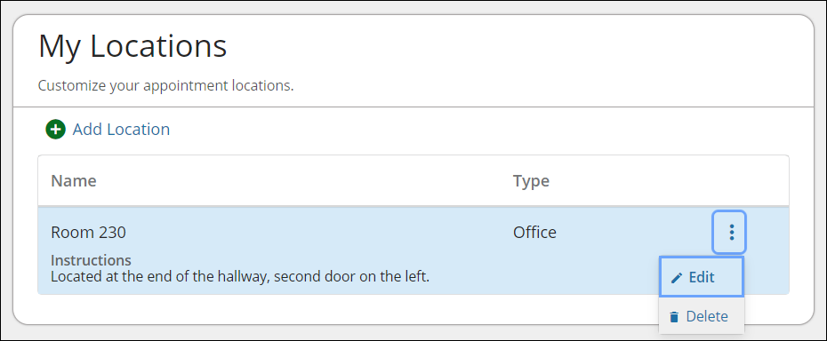
Edit Locations
You can edit your locations by selecting the ellipsis icon, then select Edit within the My Locations section. Alternately, you can remove a location by selecting Delete.

Add Office Hours
- Select Office Hours on your Starfish Home page.
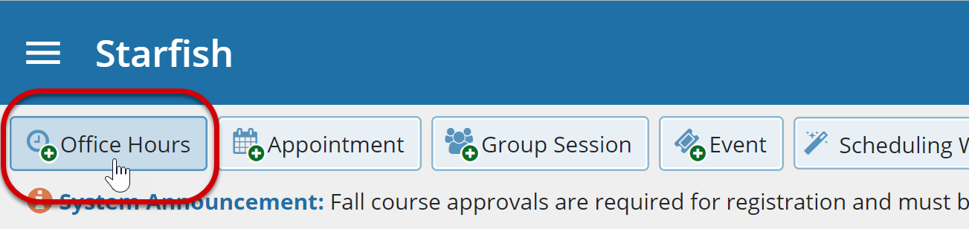
The Add Office Hour form displays.
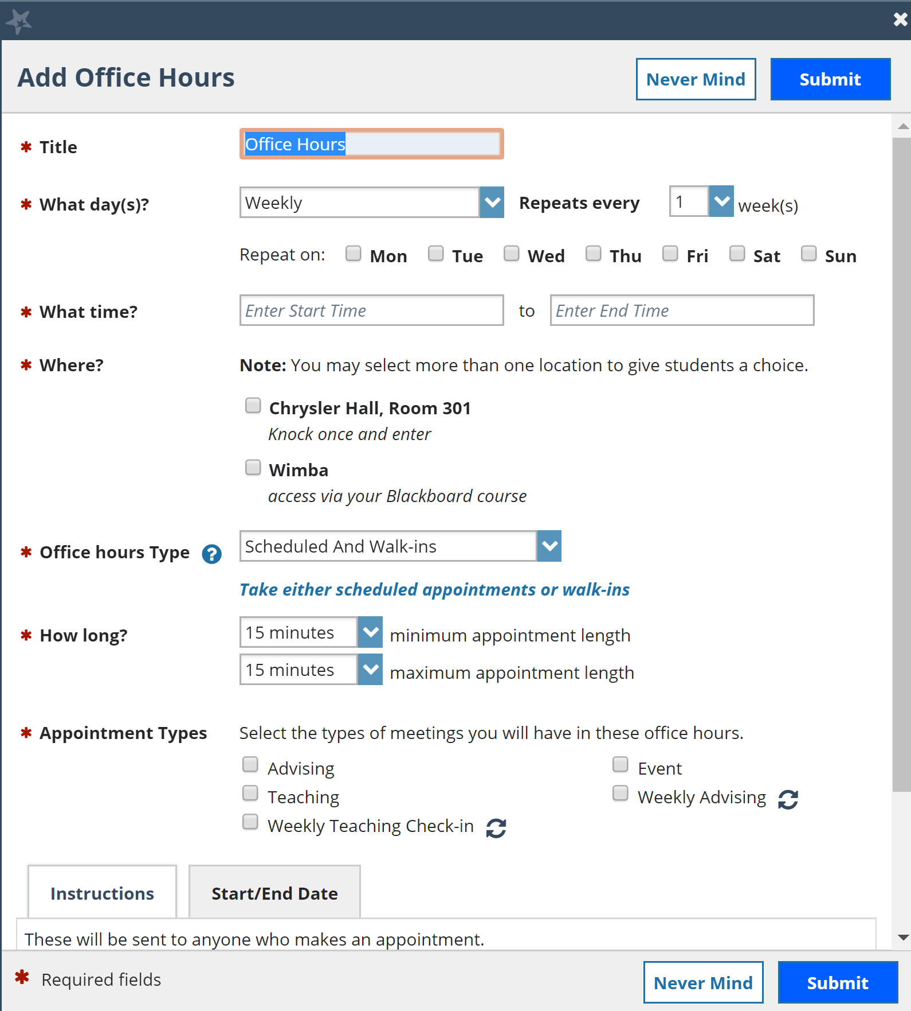

- The Title for this block of time displays Office Hours by default. However, you can change the Title to help you or others managing your calendar identify different types of office hours.

- Select What day(s)? and indicate any recurrence (e.g. Repeats every 1 week).
- Use the What time? fields to enter the start and end time for the office hours.

Once this office hour block is saved, you will not be able to edit the days on which the office hours occur or the type of frequency (e.g. weekly) but you will be able to edit how often the block recurs (e.g. 1 week vs. 2 weeks) and the specific times available.

- Select Where? meetings will be held using the checkbox(es) next to your location(s). If you choose more than one location, the student will be able to choose his/her preferred location for the meeting. To add additional locations options, go to the Appointment Preferences page of your Profile.

- Select the Office Hour Type dropdown for meetings you will take during this block.

  - Select Scheduled and Walk-ins if you will be using the kiosk/waiting room features, and you plan to take walk-ins between appointments.

  - Select Scheduled Appointments Only if you will not take any walk-ins.

  - Select Walk-ins Only to show the time as available to students but disallow anyone from making advance appointments.

- Select How long? meetings can be by selecting a minimum and maximum duration. If the minimum and maximum are identical, the student will not be given a choice of duration. Note that institution settings for specific appointment reasons, may override your settings.
- If your role has permissions to add more than one Appointment Type, you will see checkboxes that allow you to select which types apply to this block of time. Appointment Types dictate:

  - which students can schedule during this time (based on the role that connects you and the student)
  - the appointment reasons shown to students

  - which SpeedNotes will display

  - which roles can view the appointment and its notes

An appointment type with the recurrence icon indicates an appointment that recurs on the same date and time for the duration of the term.

- At the bottom of the form, use the Instructions box to enter instructions to students scheduling with you during this block of time. Instructions are required for blocks that allow Walk-ins.

- Optionally, select the Start/End Date tab to set a time frame for a repeating office hour block. For the End Date, you may choose: Never, End of Term, on a specified date, or after a specified number of occurrences.
- Select Submit to save your Office Hour block.

Scheduling Wizard (ideal for less structured office hours)
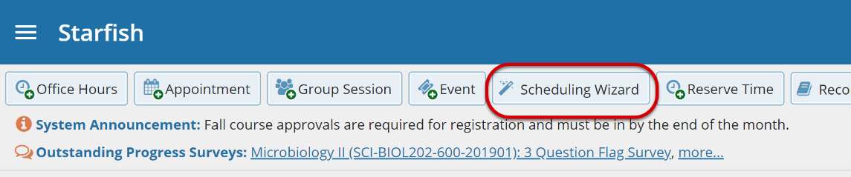
The Add Office Hours option is geared toward setting up a recurring block of time on a regular pattern such as weekly or daily at a certain time. If you want to set up a group of Office Hours that are less structured, use the Scheduling Wizard.

This feature is particularly useful for advising rush weeks, midterm course meetings, or other scenarios where you need to hold several different office hour sessions for students within a week or two.

- Select Scheduling Wizard from your Home page.

- Complete the first page of the Scheduling Wizard by entering the Title, location Where, duration How long, Appointment Types and Instructions that should be applied to all the office hour blocks that are to be created. (You will find additional descriptions of these fields in the Add Office Hours section).

Any office hour block that does not share these details must be created separately.

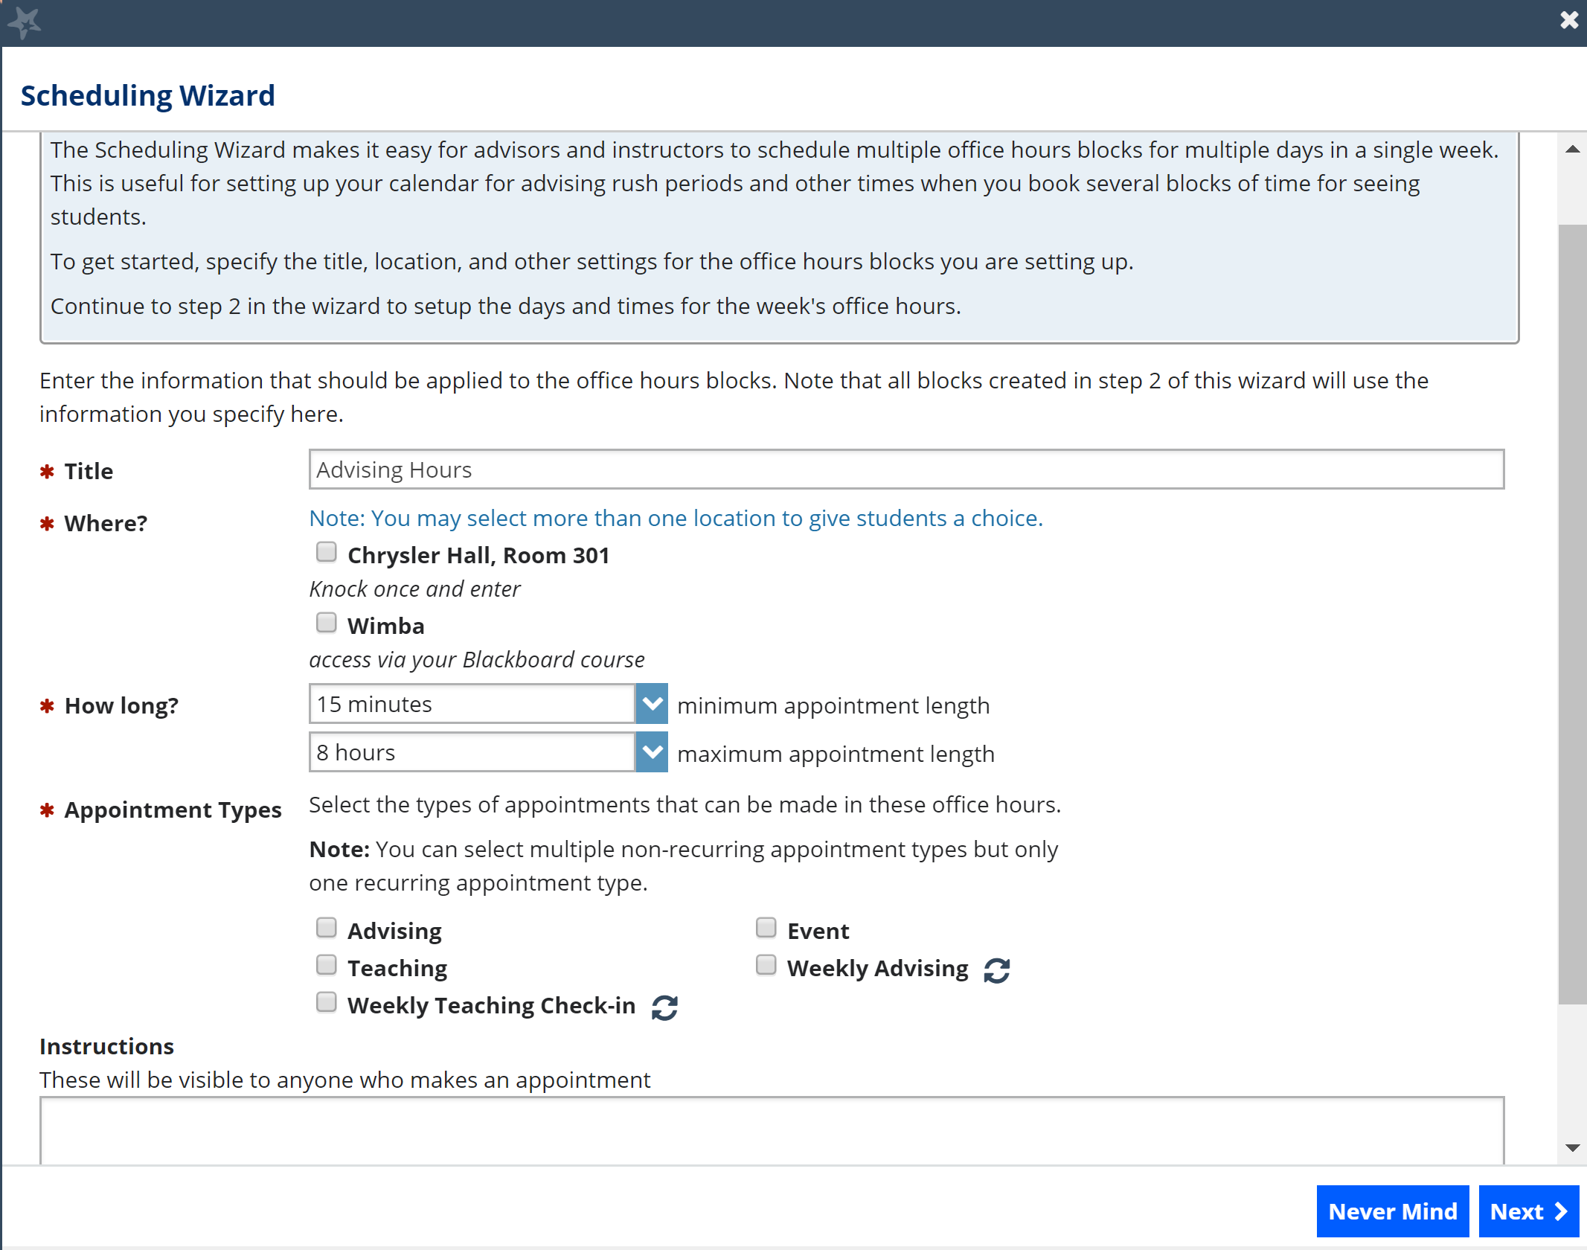

- Select Next.
The Date and Time page of the wizard is displayed using a Monday through Friday grid for the current week.
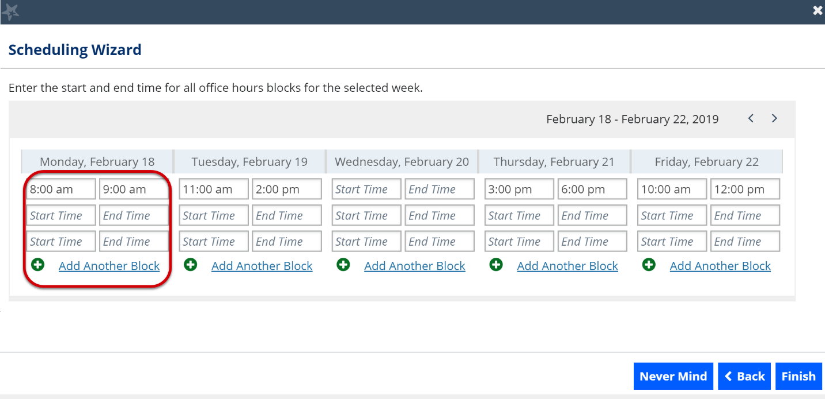

- The date range is displayed in the top right corner of the grid. Use the < > controls to the right of the date range to navigate to the week in which you want to begin scheduling the office hours.

- In the selected week, enter the start and end times for each block in the appropriate day columns. You can schedule multiple office hour blocks on any day within the week.

If you need to schedule more than three blocks on any day, select the Add Another Block link in the column for that day.

- To add blocks to another week, use the < > controls to move to the next week. Don't select finish until you've entered all the blocks!

- Select Finish to create all the office hour blocks. A summary window displays.

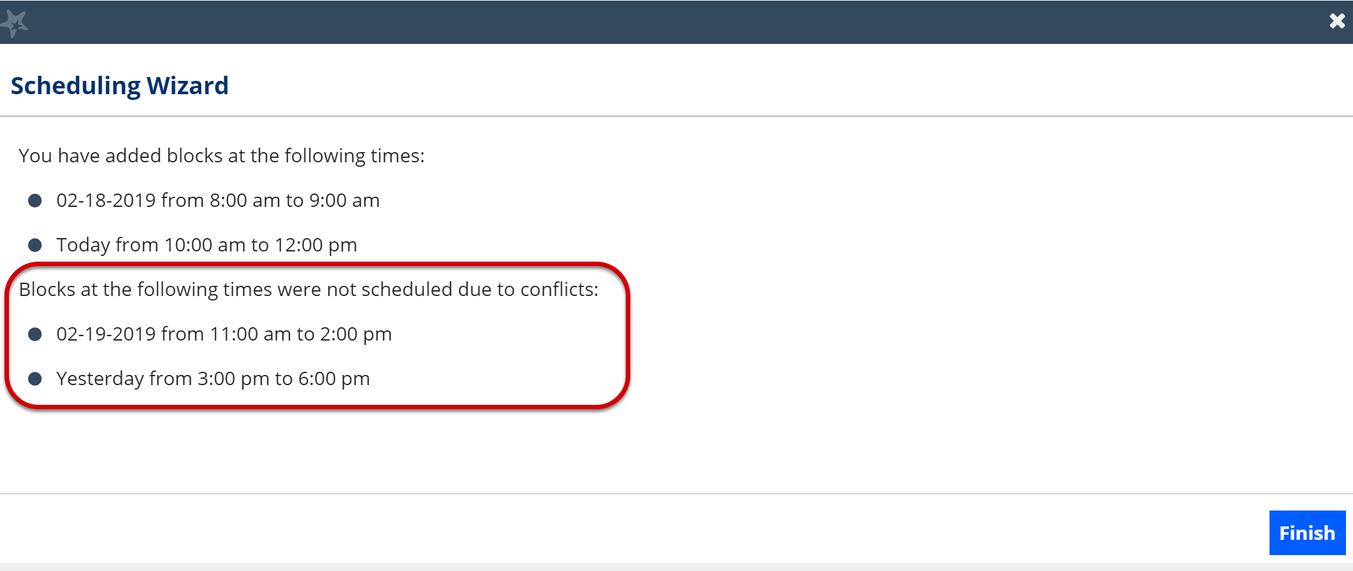

- The summary will include a list of hours that were added successfully. Any block that could not be created due to will also display. Make a note of failed blocks before selecting Finish to exit the wizard as necessary.

Manage Office Hours
Edit or cancel a series of office hours from the Agenda tab in the Appointments section of Starfish.
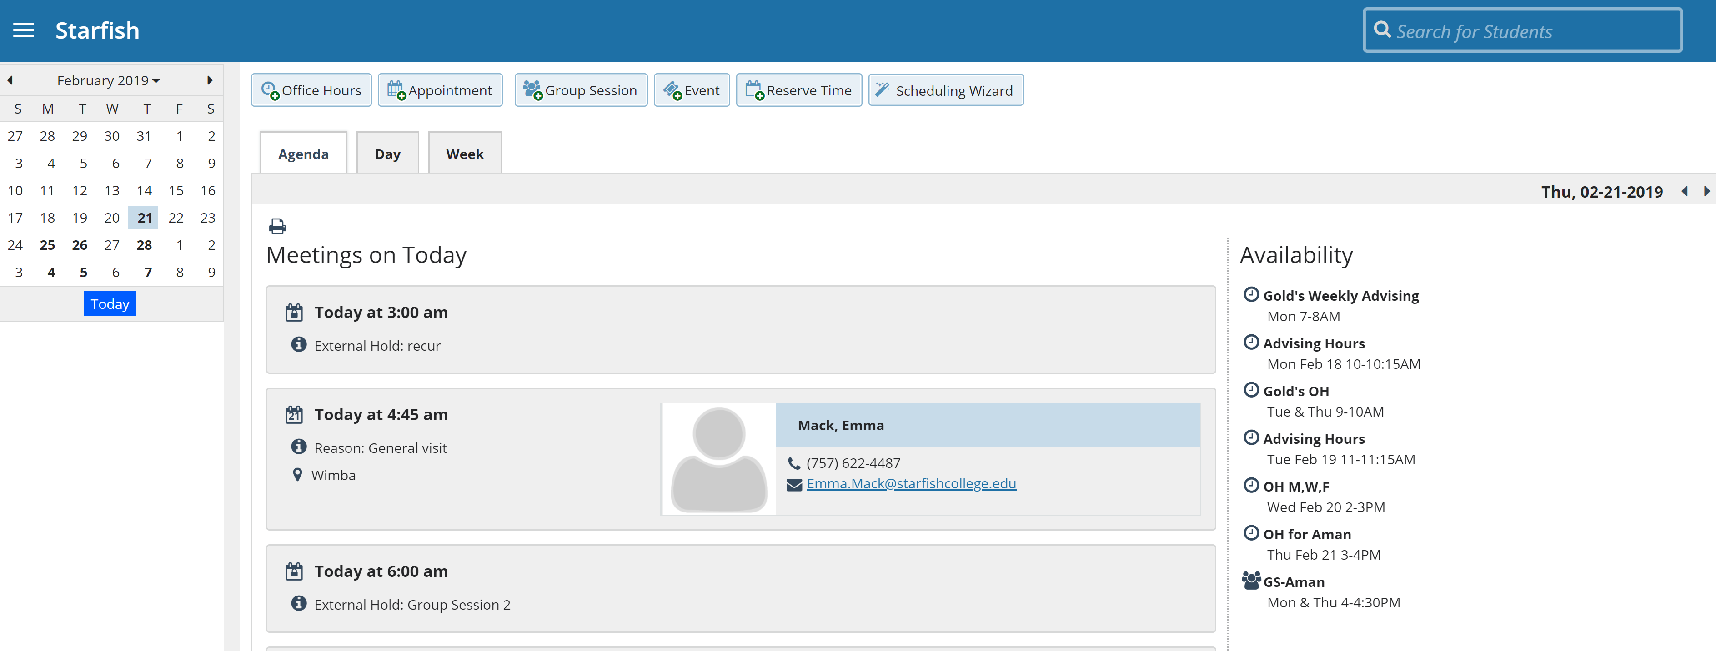

Edit office hours
- Hover over the office hours menu icon next to an office hour title to open the Office Hours pop up card.
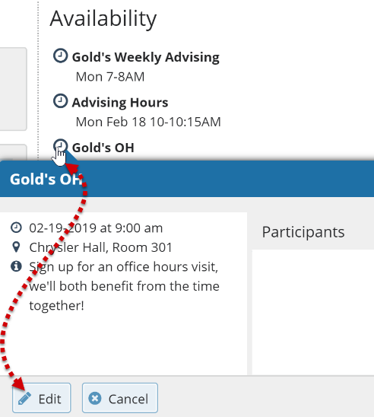
- Select Edit to modify: the frequency of the office hour block’s recurrence, the time of day, locations, office hour types, minimum and maximum duration of appointments, appointment types, instructions, or a start/end date of the series.

- Select Submit on the Edit Office Hours form to save your changes.

You cannot edit the days of the week or the nature of the recurrence (e.g. weekly).
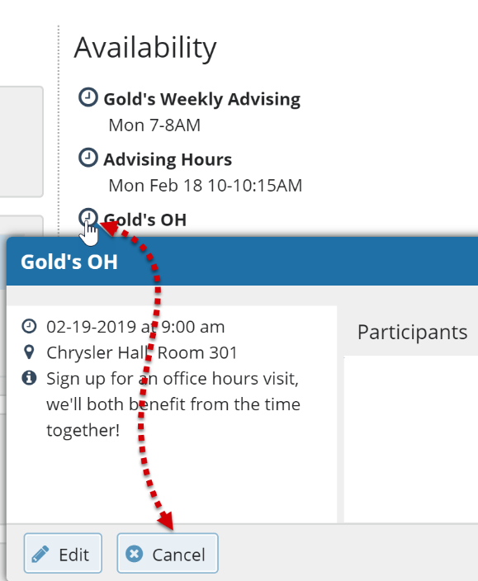
Selecting Edit will modify all occurrences of this set of office hours. To reduce availability within an office hour block on a specific day, add reserved time (See Add Reserved Time for more info) to cover the part of the office hours you want to remove from availability.

Delete Office Hours
- Hover over the office hours menu icon next to an office hour title to open the Office Hours pop up card.

- Select Cancel to open the Delete Office Hours window.

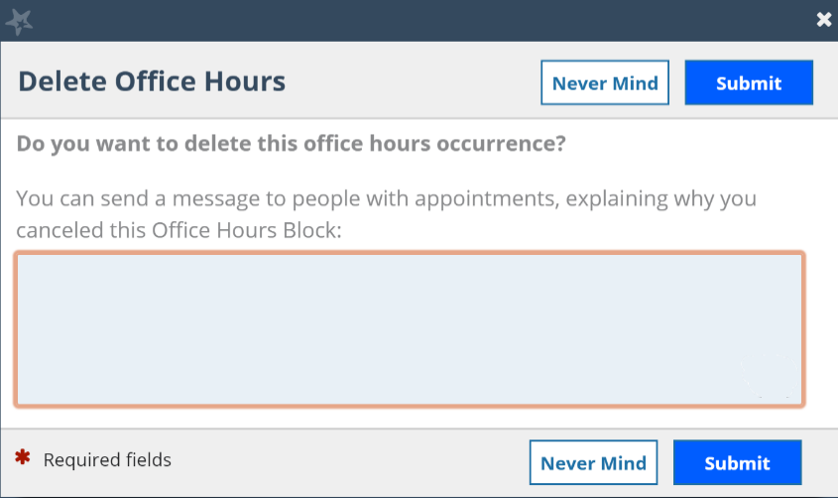
- Select Submit on the Delete Office Hours widow to remove the office hour block.

Cancel a single occurrence of an office hour block
Cancel an individual occurrence of an office hour series from the Day tab of your Appointments section of Starfish.
- Use the mini calendar on the left side of the page to select the desired day.
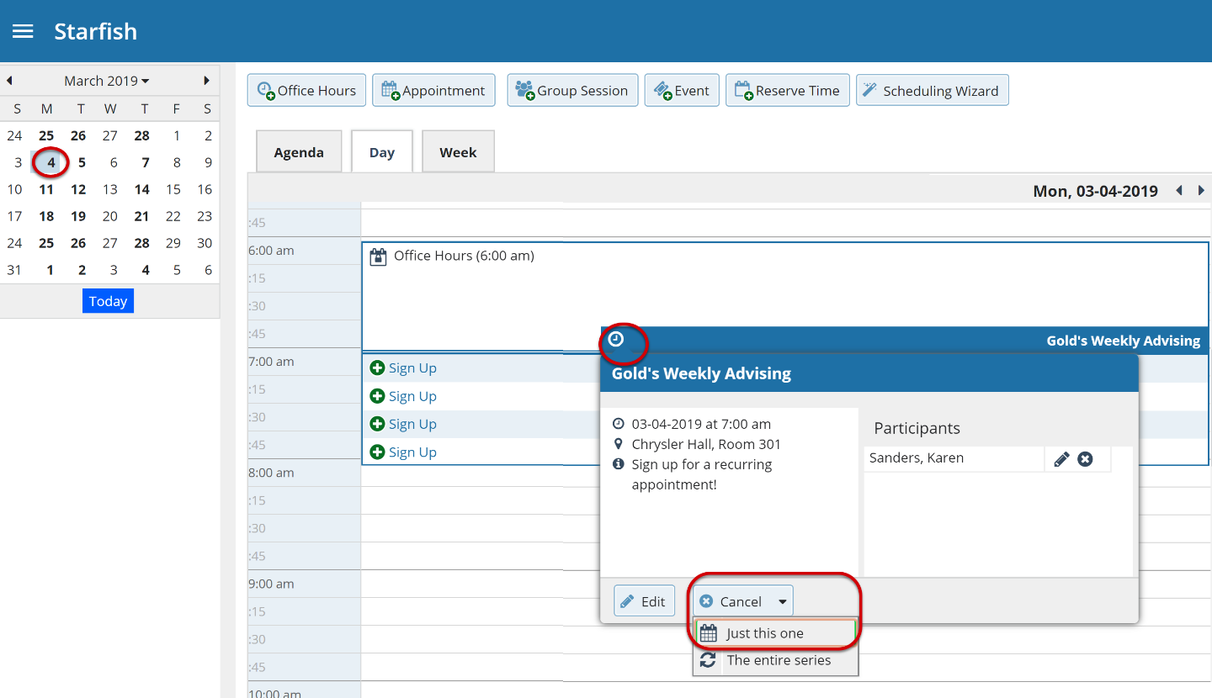

- Hover over the icon associated with the block of hours for the selected day.

- Select Cancel from the pop-up card that is displayed then select Just this one to cancel office hours for the selected day. You will be prompted to confirm the cancellation and can add a note that will be included in an email to those whose appointments are canceled.

Starfish recommends including an explanation and provide guidance on how to reschedule or connect to other available resources.
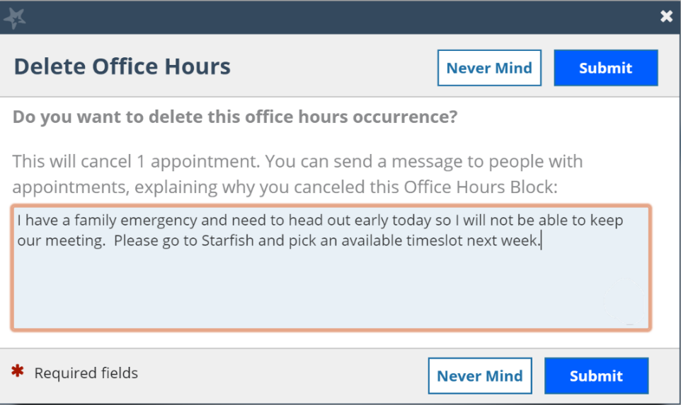

- Select Submit to cancel the Office Hour occurrence.

Add Appointments
- Initiate a new appointment using one of two ways:

  - Select Add Appointment from your Home page.
  - Select the Sign Up icon for an existing office hour slot using the Day or Week view of your calendar on the Appointments page.
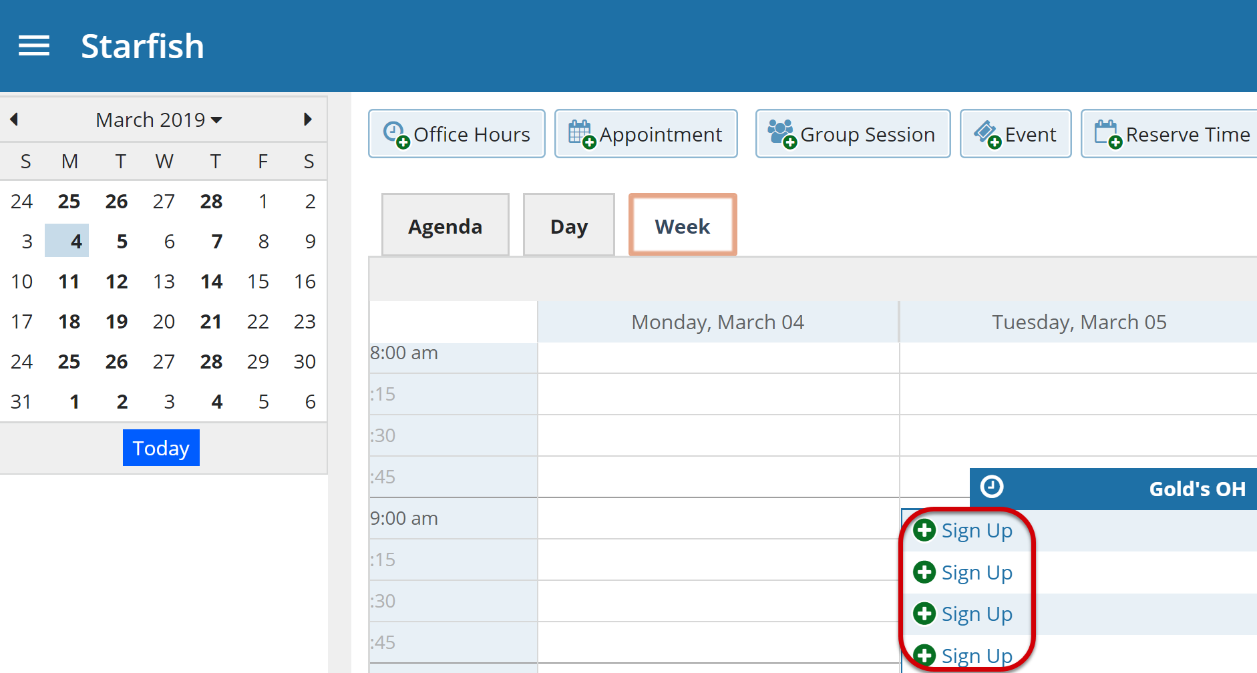
Using either method, the Add Appointment form displays.
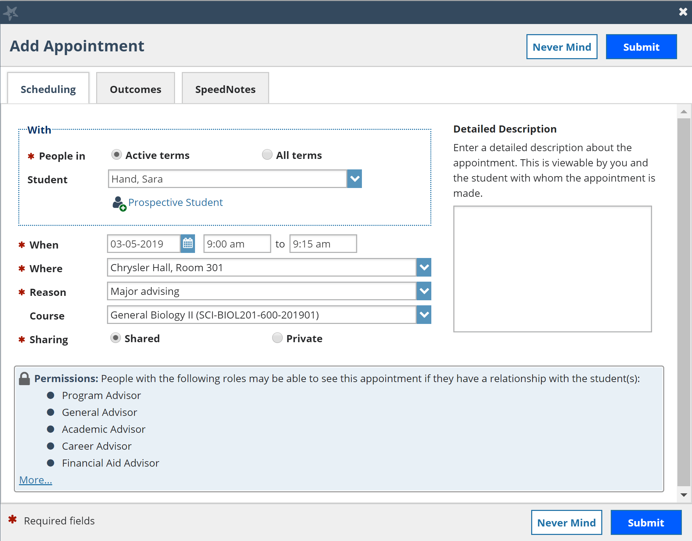
- In the People in field, select the appropriate Term for the student.
- In the Student dropdown, enter the student name. Starfish will find matching students with whom you have a relationship. Select the appropriate student from the list.

- If you start the appointment from an existing office hour block, the Appointment Types setting in that block may further limit the students available in your list. Alternately, if you used the Add Appointment button rather than selecting an existing time slot, specify When the meeting will take place (date, start time, end time).

- Select the location in the When drop down list.

- Select a Reason for the meeting. The reasons available are based on the student you selected and the Appointment Types that you have access to in your role/ relationship with that student.

Each reason is tied to an appointment type. Each appointment type defines which roles may view or modify an appointment of this type, and the available SpeedNotes. Once you choose a reason, information about which other roles have permission to see the appointment will be shown in the section labeled Permissions.

- If you selected a timeslot from a set of existing office hours, the reasons will be further limited to those associated with the Appointment Types settings for the office hours.

- If relevant to the meeting and permitted by your role, select a Course from the list presented.

- Select the appropriate Sharing settings for this appointment.

- Enter a Detailed Description which will be emailed to you and the student.

- Select Submit.
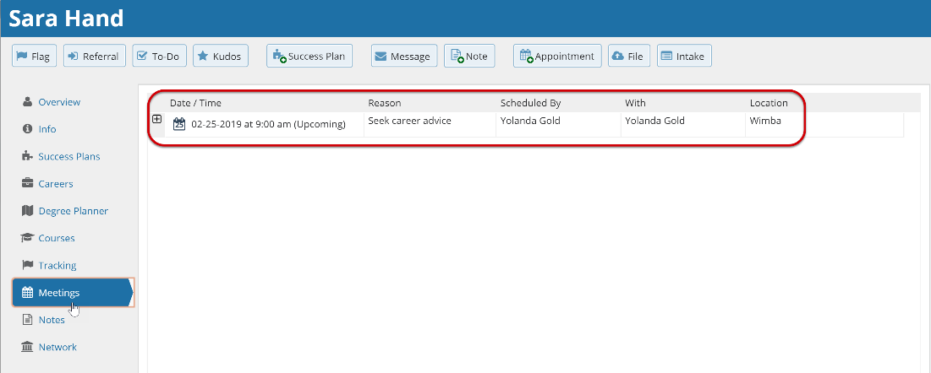
The appointment displays on your Calendar, Home page, and Recent Changes channel. Additionally, the appointment, along with the detailed description displays on the Meetings tab of the student folder for anyone that has permission to view the appointment.
Both you and the student will receive an email with an iCal attachment for any future appointments. Appointments created to document prior meetings will not send an email. If you do not receive an email, check your Email Notification settings.

Manage Appointments
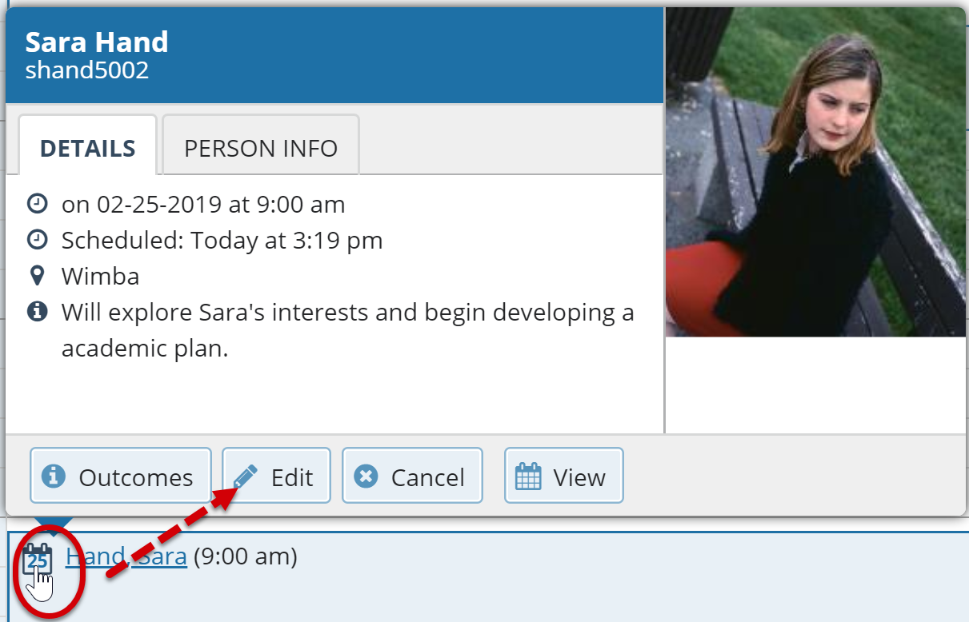
From the Appointments pop up card you can edit or cancel an upcoming appointment and add or edit outcome details. If configured on your Starfish system, you may be able to use SpeedNotes to document common outcomes.

Scheduling
- Hover over the Appointment icon .
- Select Edit to open the Scheduling tab. From here, you can edit appointment scheduling details including:
  - When and Where the appointment will occur.
  - The Reason associated with the appointment.

The Reason selection may impact who else can view the meeting, and which SpeedNotes will be available for documenting outcomes.

  - The Course associated with the appointment. (optional)
  - The Sharing setting.
  - The Detailed Description that is shared with the student and documented on the Meetings tab of the student folder.

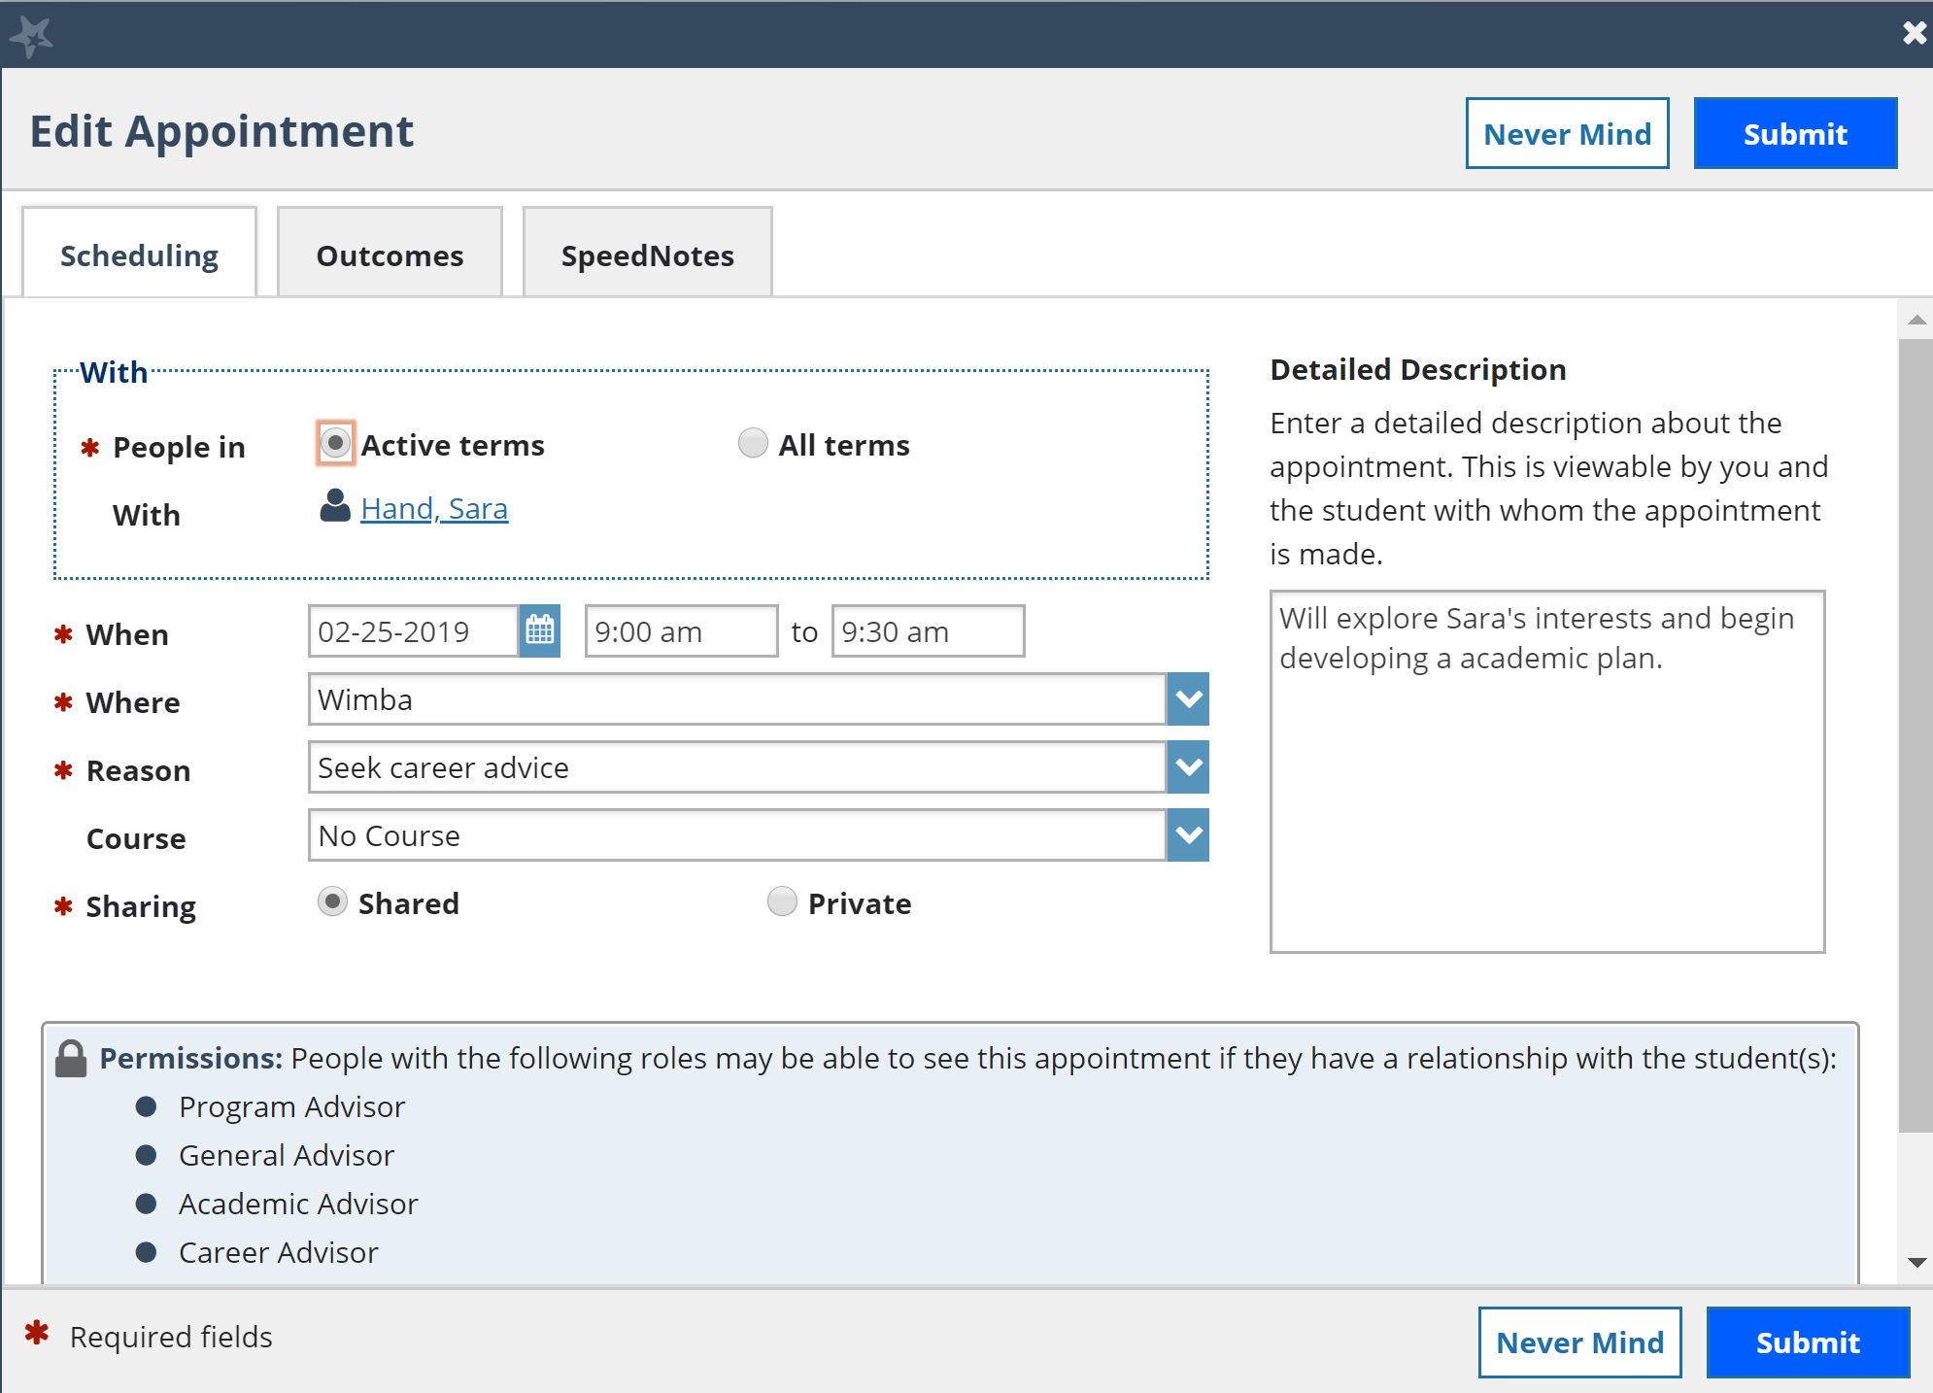
- When finished, select Submit.

An updated iCalendar (iCal) attachment will be emailed to the student. You will also receive the updated iCal if your Email Notifications preferences are set to notify when changes are made to an existing appointment (recommended).

Outcomes
- Hover over the Appointment icon .

- Select Outcomes.
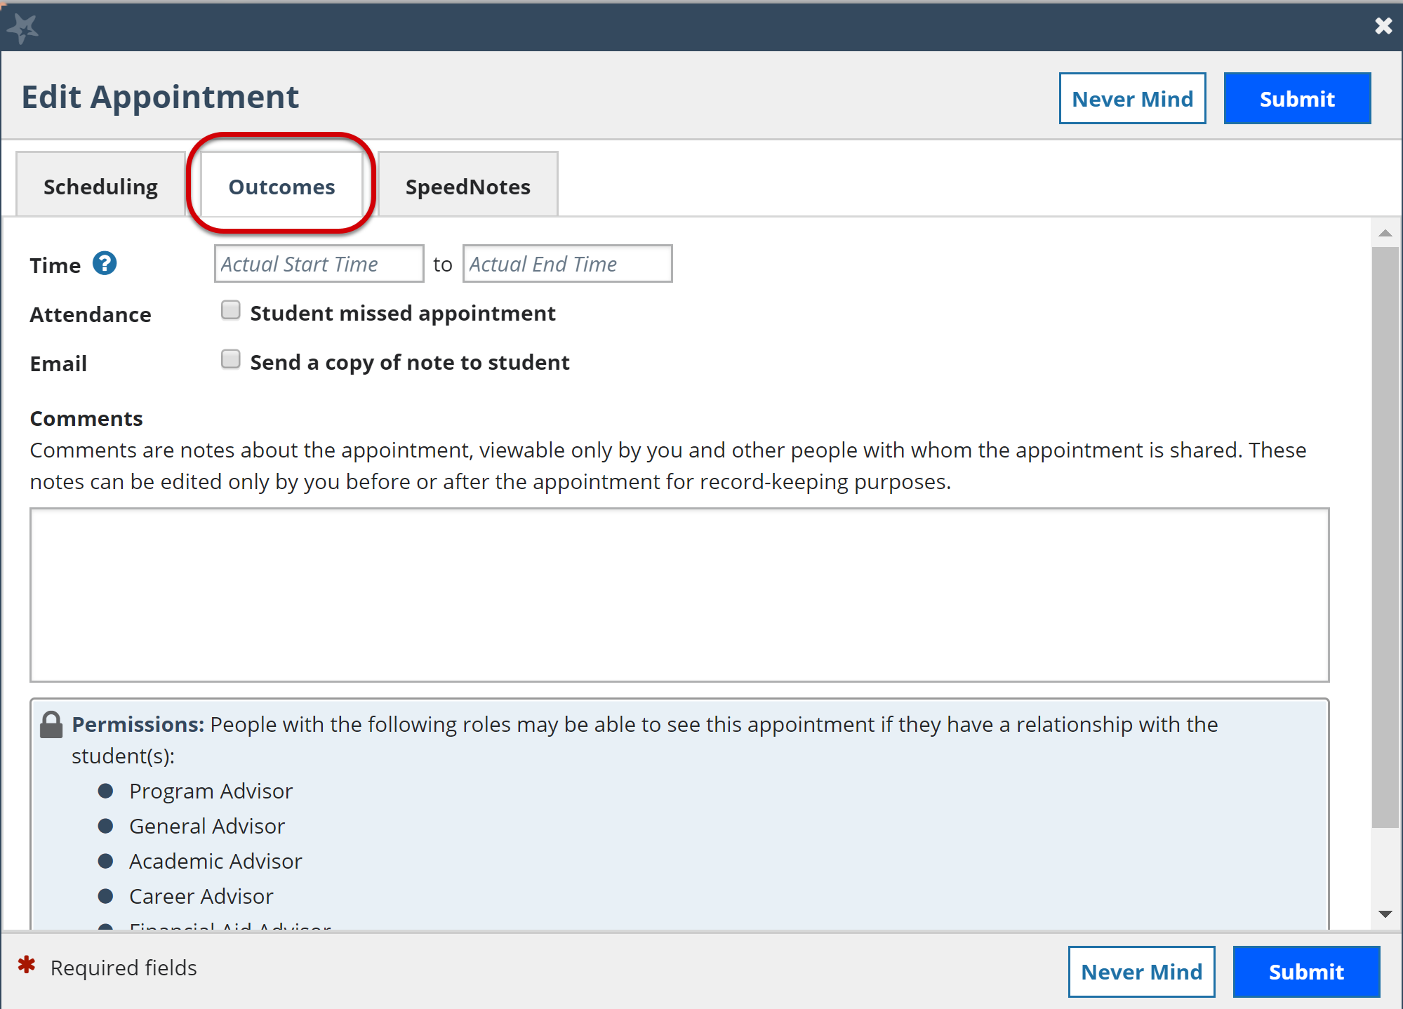

- In the Time fields enter the meeting’s actual start and end time.

- Select the Attendance checkbox if the student missed the appointment. Depending on your institution’s settings, this may trigger an email to the student.
- Select the Email checkbox if you would like to send a copy of the Outcome note to the student.

- Enter your notes into the Comments box.

- When finished, select Submit.

The Outcome notes will be available in the student folder on the Meetings tab for this appointment.

SpeedNotes
SpeedNotes are preconfigured appointment activities that can be selected to quickly capture recurring meeting outcomes. If SpeedNotes exist for any appointment types in your Starfish system, the SpeedNotes tab is available whenever the Edit Appointment form is open.
If the selected appointment type has no SpeedNotes associated with it, the tab contents will be blank.

The Reason selected for your appointment on the Scheduling tab is connected to an appointment type, and that appointment type determines which SpeedNotes are displayed. If you don’t see the SpeedNotes you were expecting, you may need to select a different Reason or check with your Starfish Administrator.

- Hover over the Appointment icon associated with an appointment.

- Select Outcomes or Edit from the Appointment pop up card.

- Select SpeedNotes.

- Select the items that are relevant to your meeting.
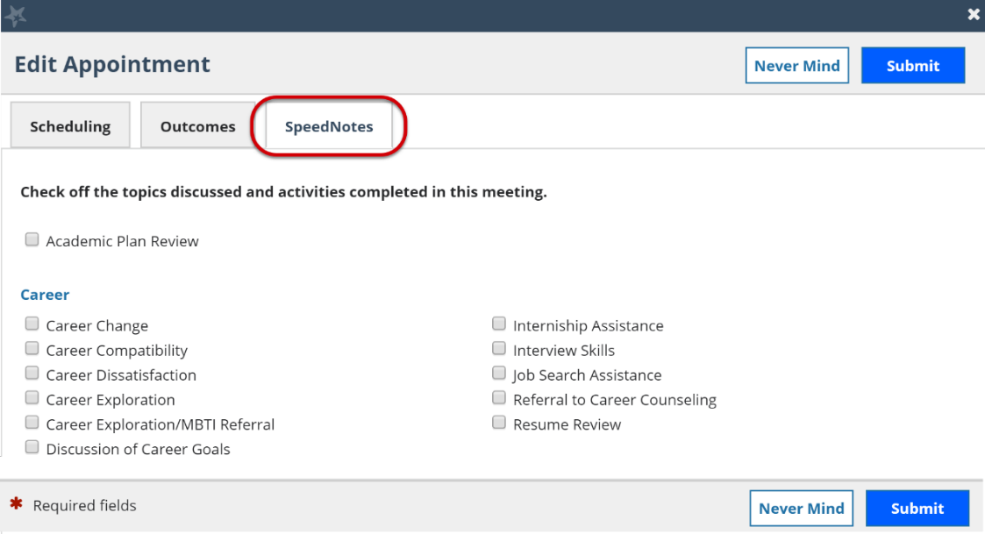

- When finished, select Submit.

Cancel Appointments
- Hover over the Appointment menu icon .

- Select Cancel.

- The Cancel Appointment form is displayed. Enter a note explaining the reason for the cancellation.

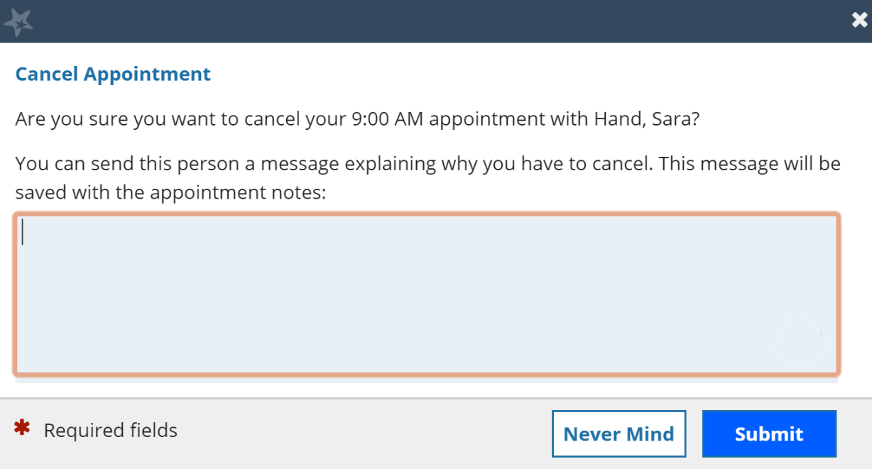
- Select Submit to cancel the appointment.
An updated iCalendar (iCal) attachment will be emailed to the student. You will also receive the updated iCal if your Email Notifications preferences are set to notify when changes are made to an existing appointment (recommended).

Review Appointment information and meeting outcomes
- You can open the student folder by selecting the link associated with the student’s name wherever it displays in Starfish. In this example, we will access the appointment information from the Appointment channel on your Home page.

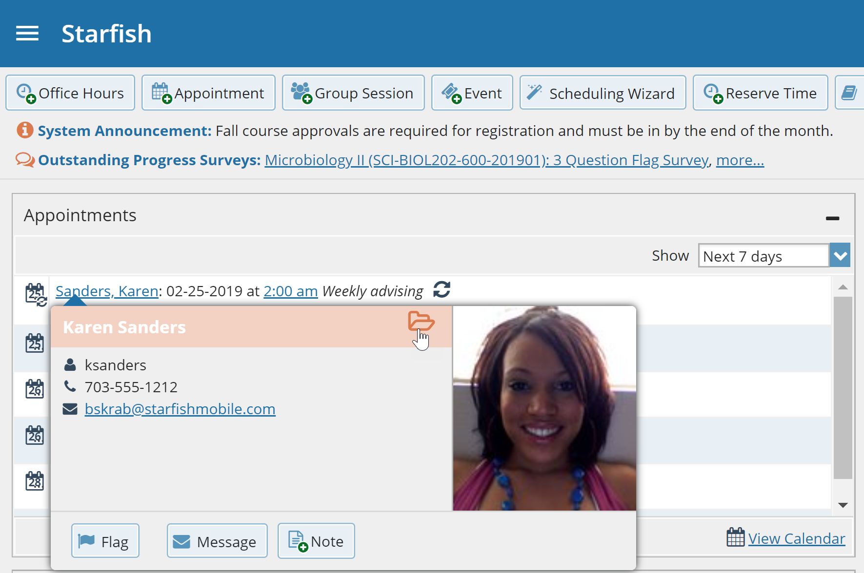
The Student Folder displays.
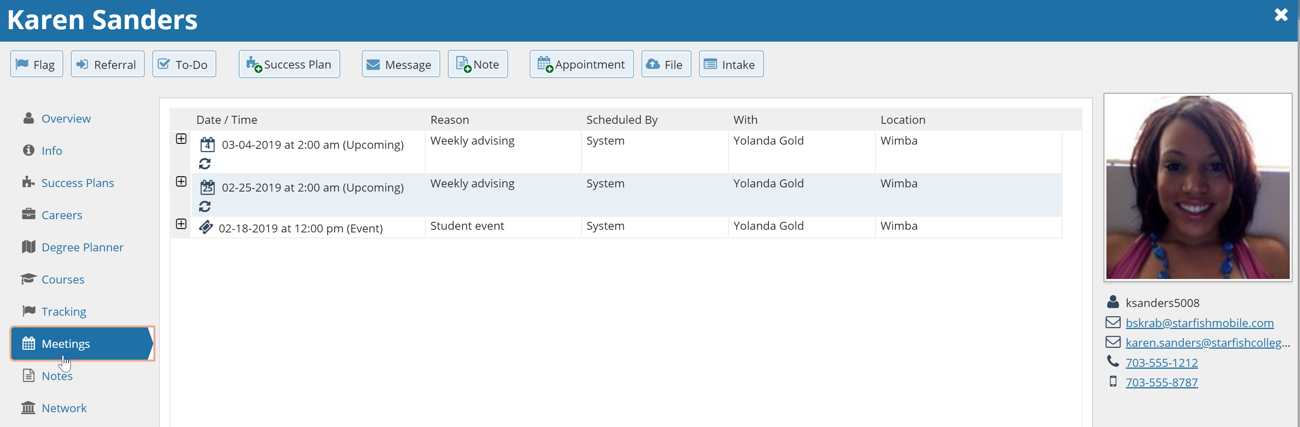

- Select the Meetings tab to review information about upcoming and past meetings for this student.
The Meetings tab of the student folder includes upcoming appointment information as well as meeting notes captured in Starfish. It may also include historical meeting information from external systems.
The information that is available to you on the Meetings tab is based on the role(s) that connect you to your students and the Appointment Types those roles have permission to view.
The icons to the left of each meeting in the list provide additional information or available actions related to the meeting:

- Expand icon : when you select the Expand icon you can view additional details about the meeting.
- Appointment icon : when you hover over the Appointment icon you can update the appointment.
- Missed Appointment icon : if the student was marked as a no show on the Outcomes tab, the Missed Appointment icon displays instead of the standard appointment icon.
- Historical Appointment icon : if your Starfish system was configured to allow external calendar meeting outcomes such as TutorTrac, you will see the Historical Appointment icon display.
- Events icon : when you add an Event, the Event icon displays in your Starfish calendar.

Filter student lists based on meetings
From the My Students tab, you can identify students that have or have not scheduled appointments.

- Select My Students from the Students menu option, then select Add Filters. The Additional Filters form displays.
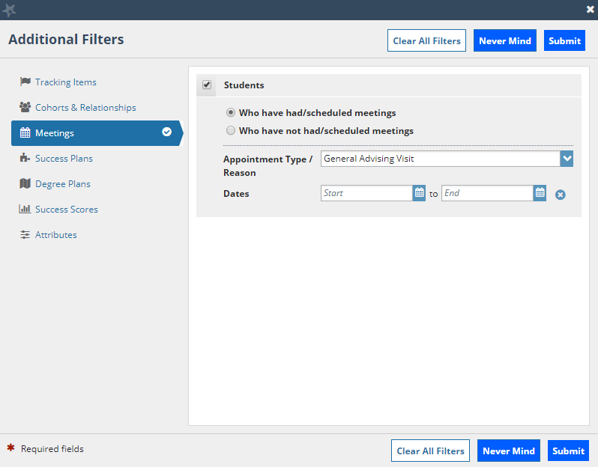
- Select Meetings from the filter options and select the Students checkbox.
- Select whether you want to filter to students Who have had/scheduled meetings” or to those Who have not had/scheduled a meeting. Alternately, you can filter to a specific Appointment Type/Reason and a range of Dates.

- When finished, select Submit.

Your student list displays students who matched your Meetings filter criteria.
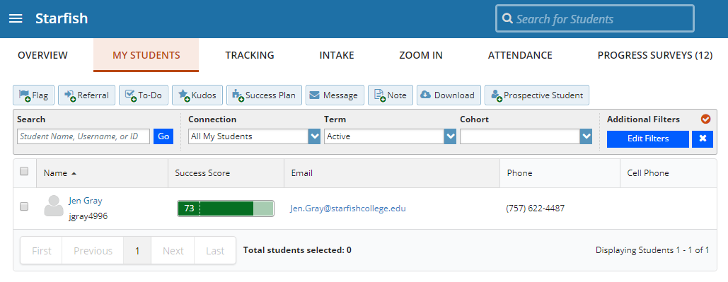
Select the Clear Filters icon to remove your filter or select Edit Filters to modify your filter criteria.

Canceled appointments will not be included in the filter results for students that have had/scheduled an appointment, but scheduled appointments where the student was marked as a no show will be included.

Group Sessions
Group sessions allow you to create blocks of time in which a specified number of students can meet with you as a group. The steps are like adding office hours but include selections that are specific to group sessions.

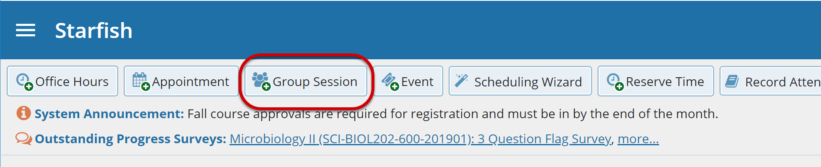

Add a Group Session
- Select Add Group Session from the Home page. The Add Group Session form displays.
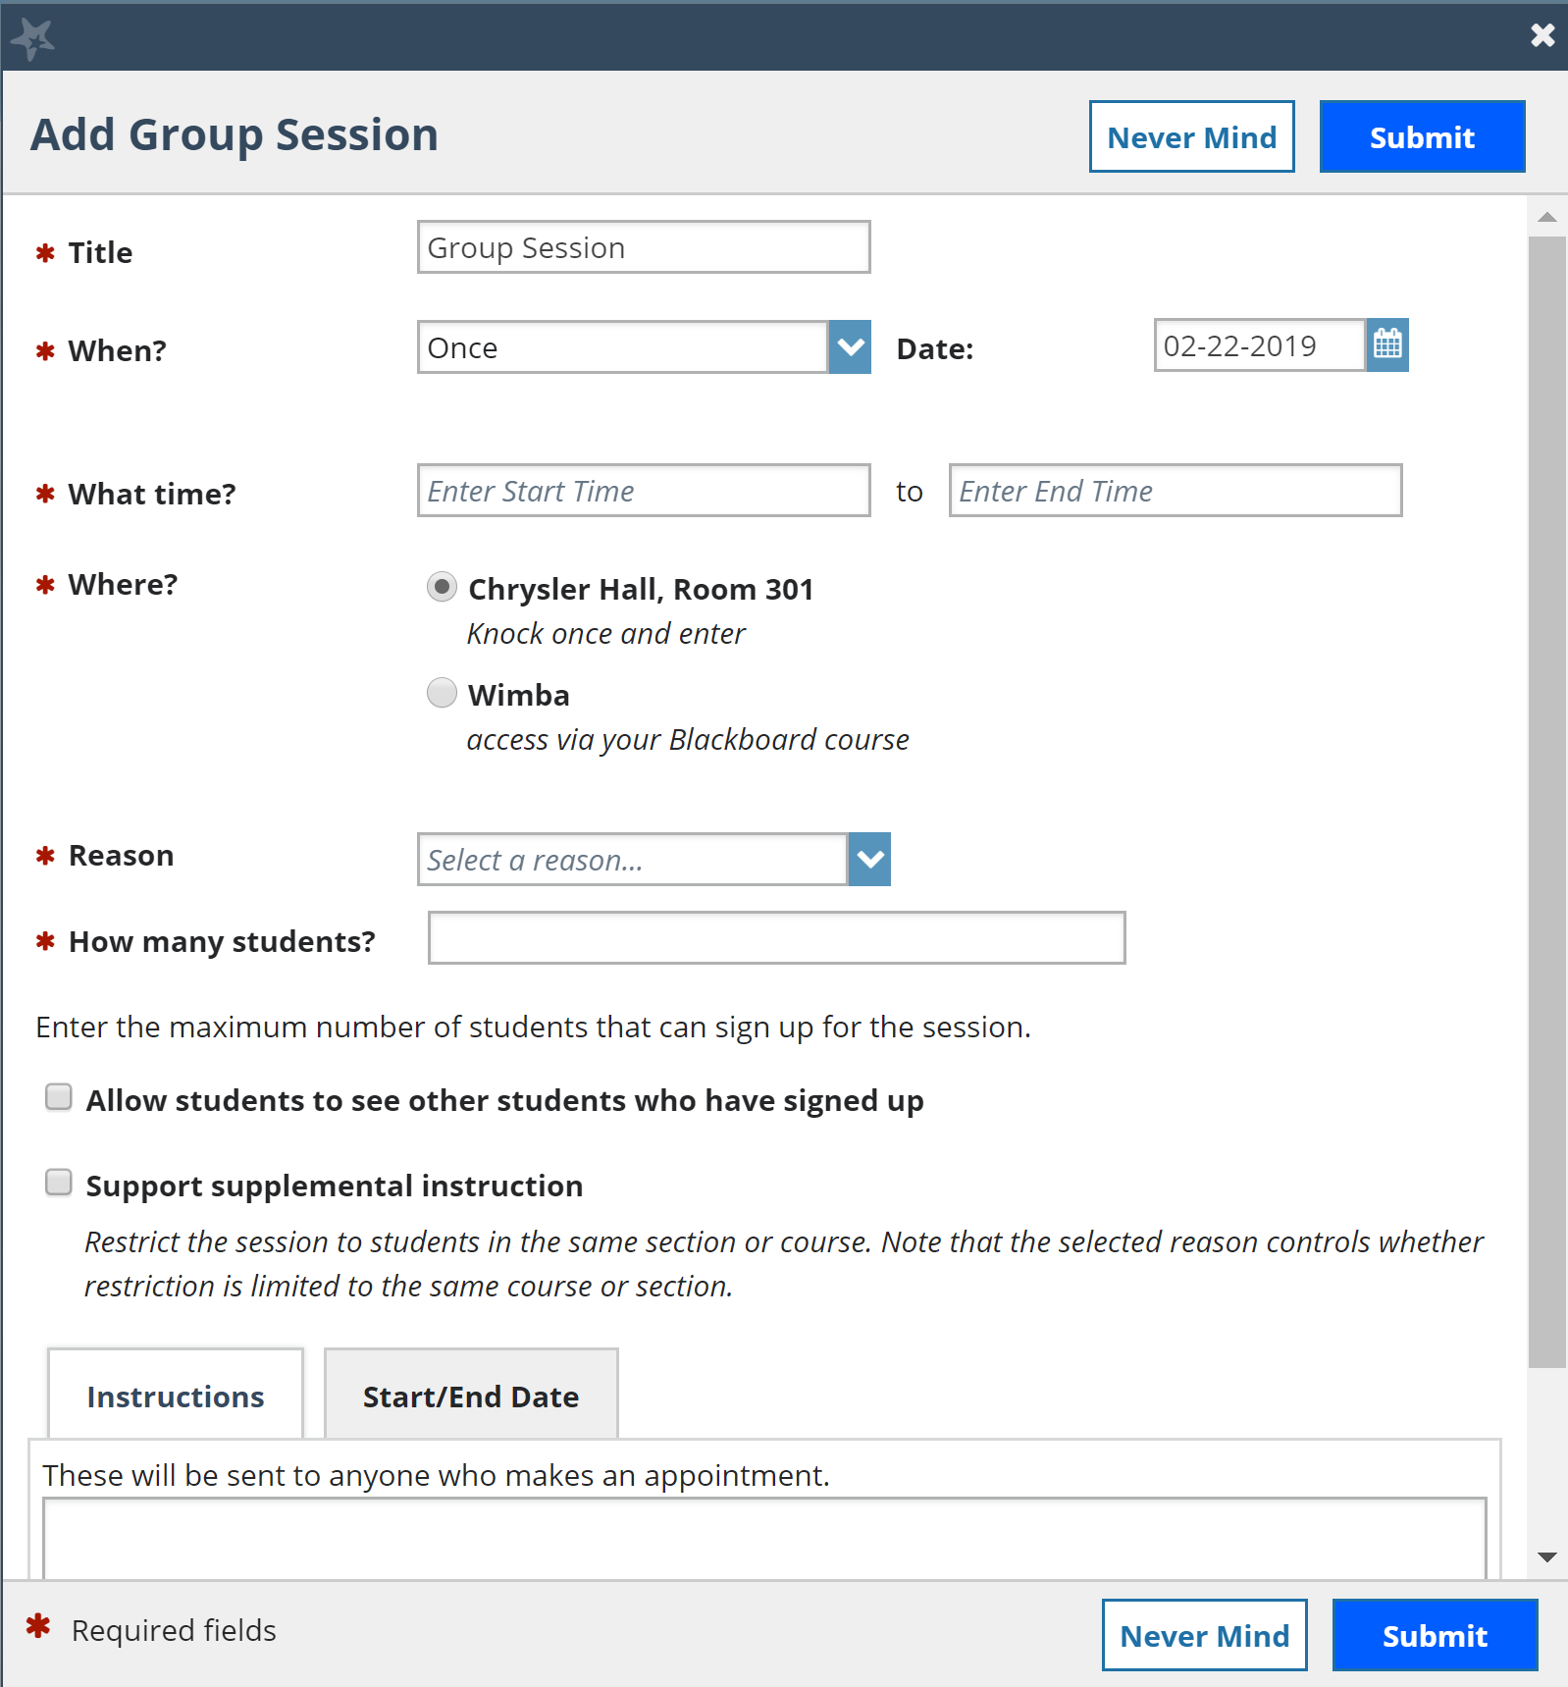

- Enter a Title for this group session. Students will see this title when they view your calendar.

- Select When? the group session will occur and select the recurrence.

- Use the What time? fields to enter the start and end time for the group session.

Once the group session is saved, you will not be able to edit the days on which the session occurs or the type of frequency (e.g. weekly) but you will be able to edit how often the block recurs (e.g. 1 week vs. 2 weeks) and the specific times.

- Select Where? meetings will be held. To add additional locations options, go to the Appointments Preference page of your Profile. Only one location can be selected for a group session.

- Select the Reason associated with this group session. Reasons listed are those associated with the Appointment Types your role has permission to add. If you don’t find the reason you expected, contact your Starfish administrator.

- Enter How many students (maximum) can sign up for the session.

- If students can see the names of other students who have signed up for the session, select the Allow students to see other students who have signed up checkbox.

- If this group session should be limited to students in the same course/ course section, select the Support supplemental instruction checkbox. When this option is selected, participants will be limited to the course/course section selected by the first student who signs up.
The supplemental instruction option is most often used with Tutoring Service Calendars. The restriction may be either course or course section based (e.g. restricted to Biology 101 students, or to Biology 101, section 02 students). This depends on options your Starfish administrator set for the Appointment Type associated with your group session reason. Contact your Starfish Admin to learn more about this option.

- Use the Instructions box for information that can be shared with students who sign up.

- Select Start/End Date to designate a time frame for the group session if it recurs (as set in step 3 above).

- Select Submit save your Group Session.
Existing group sessions will display within the Appointments section of Starfish.
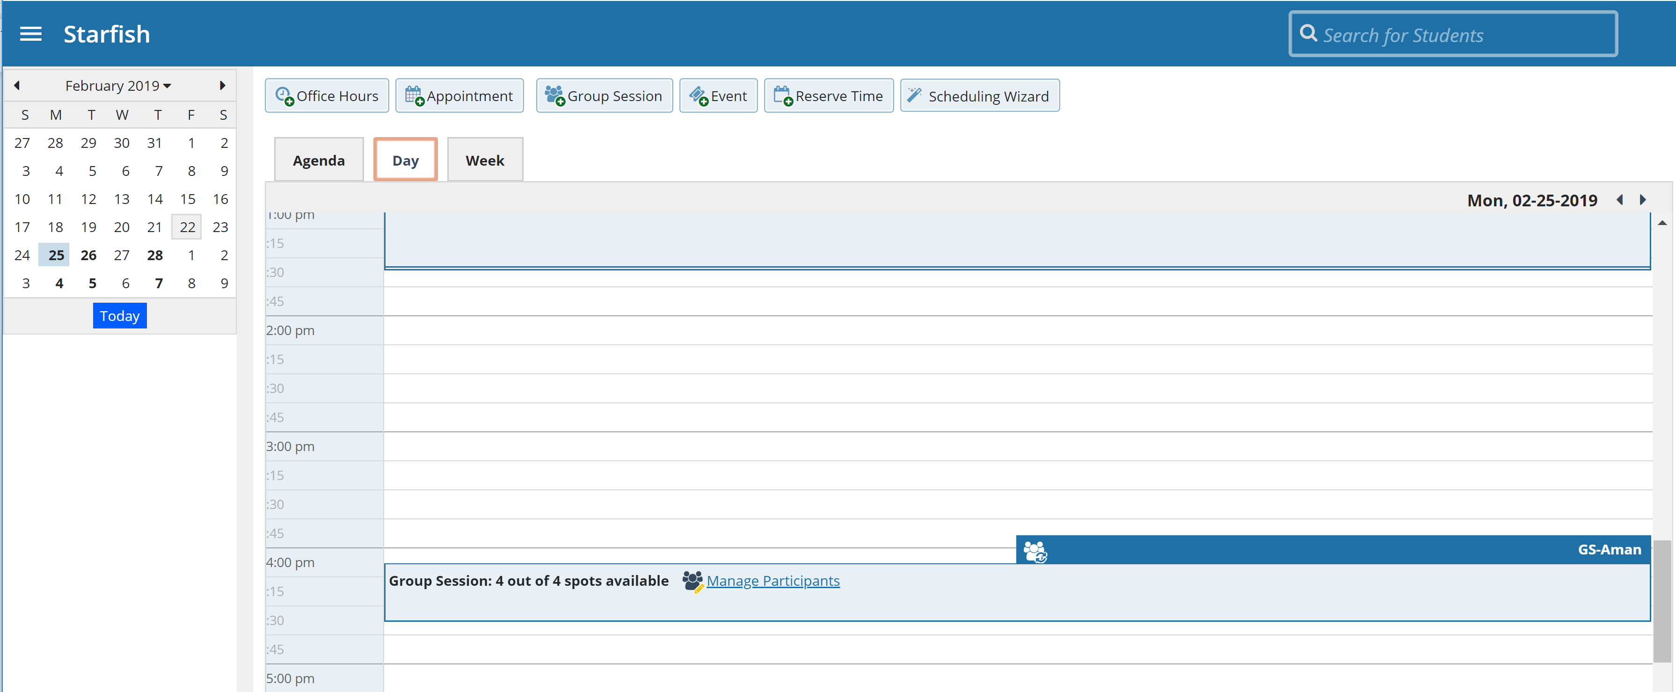

Edit a Group Session
- Hover over the Group Session icon to open the group session pop-up card.

- Select Edit on the pop-up card. You can edit the frequency of recurrence, time of day, location, reason, number of participants, visibility of students, instructions and the series start/end date.

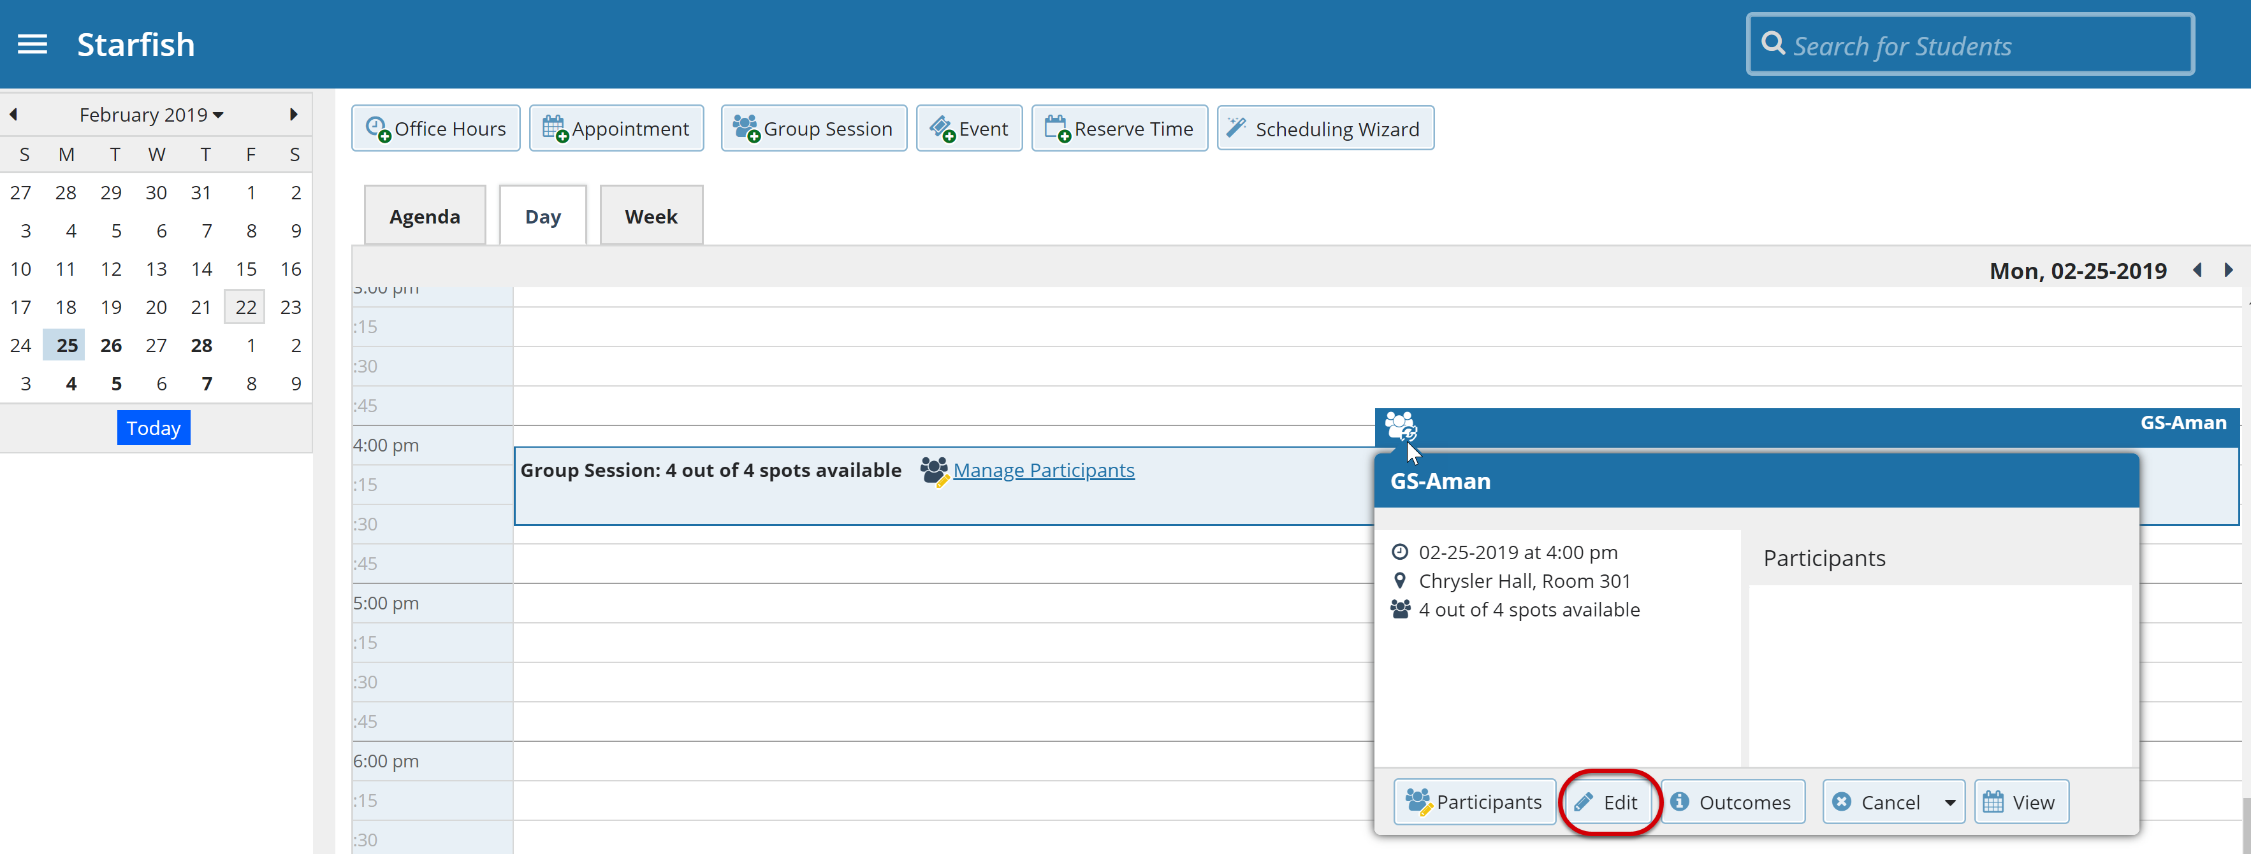

You cannot edit the days or the frequency of the recurrence (e.g. weekly). Some changes are prevented after students have signed up.
- Select Submit to save your changes.

Cancel a Group Session
- Hover over the Group Session icon to open the Group Session pop-up card.

- Select Cancel. If you select Just this one, this will cancel the session for the selected day. If you select The entire series, this will cancel all occurrences of the group session.

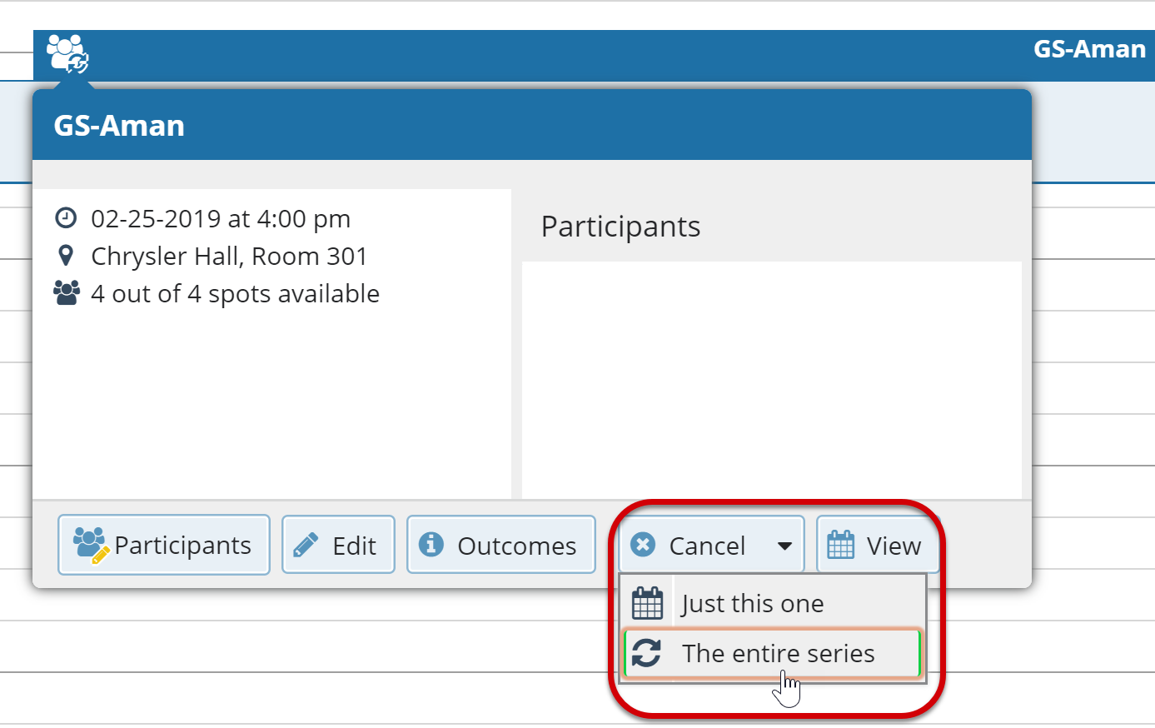

You will be prompted to confirm the cancellation and can add a note that will be included in an email to those whose session is canceled.

- Select Submit to cancel the group session series.

Manage Group Session Participants
You can add or remove participants in an individual group session using the Manage Participants link on the Day view of the group session.

Add Participants

- Select Manage Participants.

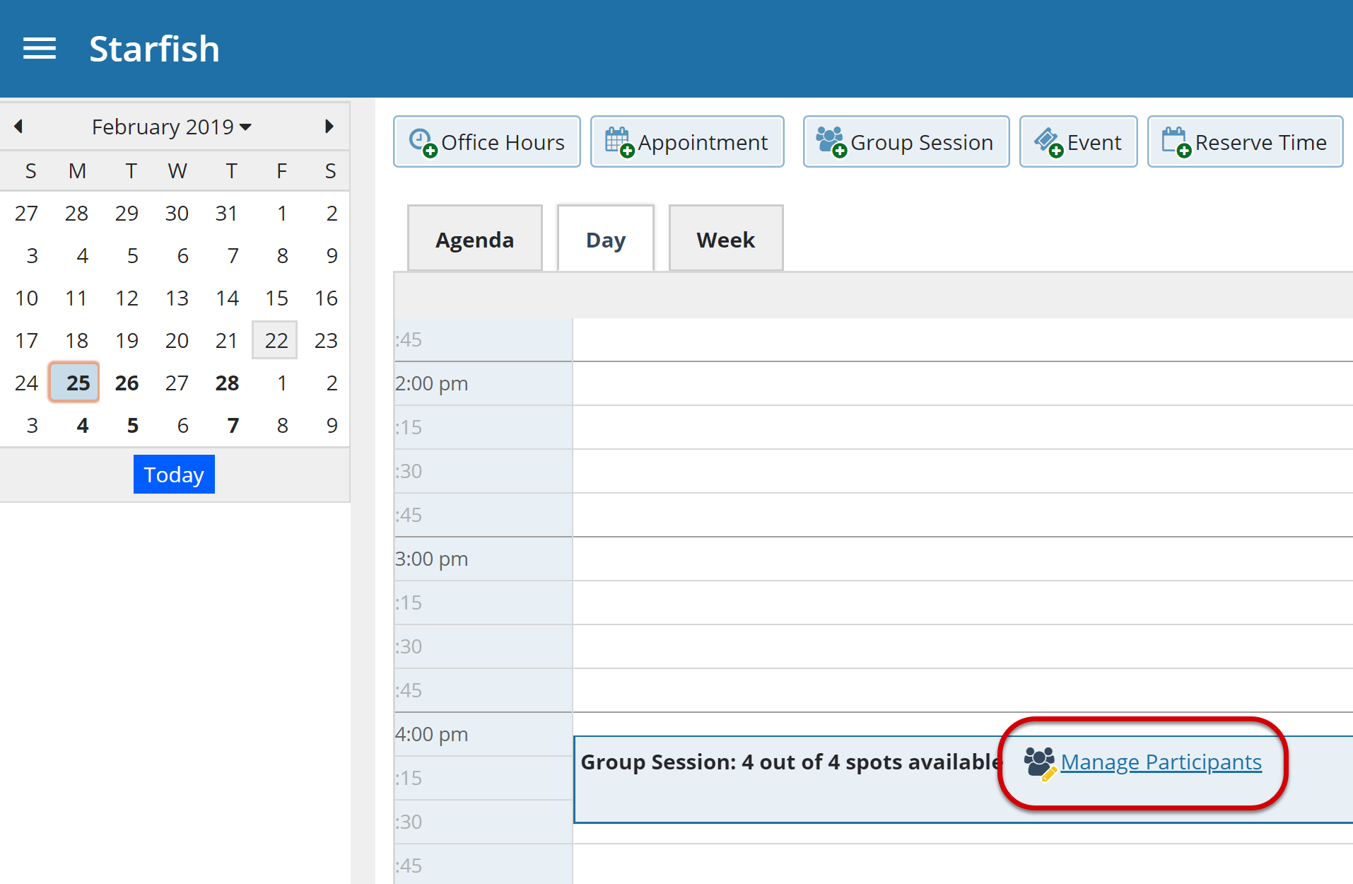

- Search for a student by typing the name into the Add participant field, then select Add. Repeat this process for each student you want to add.

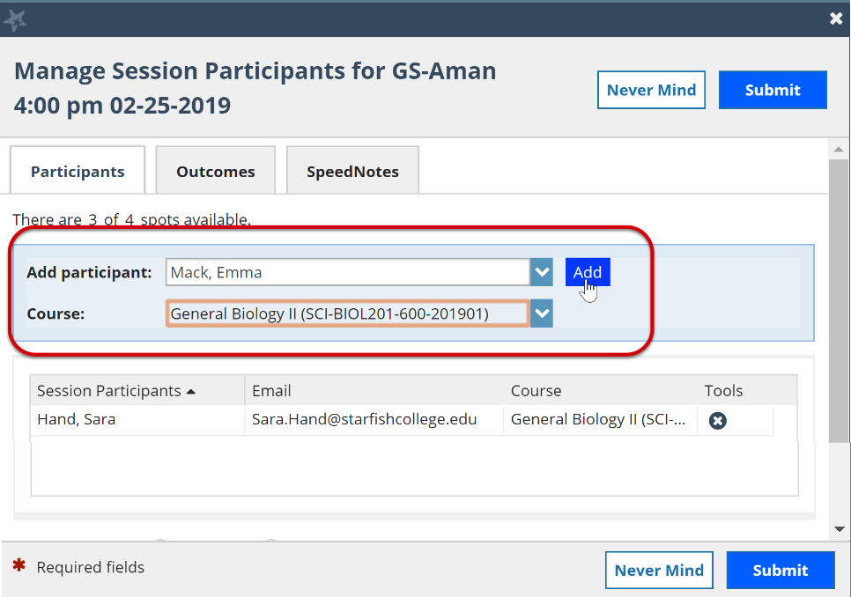

Remove Participants
- To remove a participant, select the delete icon associated with the student within the Tools column.

- When you are finished select Submit.

Session Sharing

You can mark group sessions to be Shared with people that have a relationship with the student. Starfish will display the first five people that have a relationship with the student by default, select More to display the entire list.

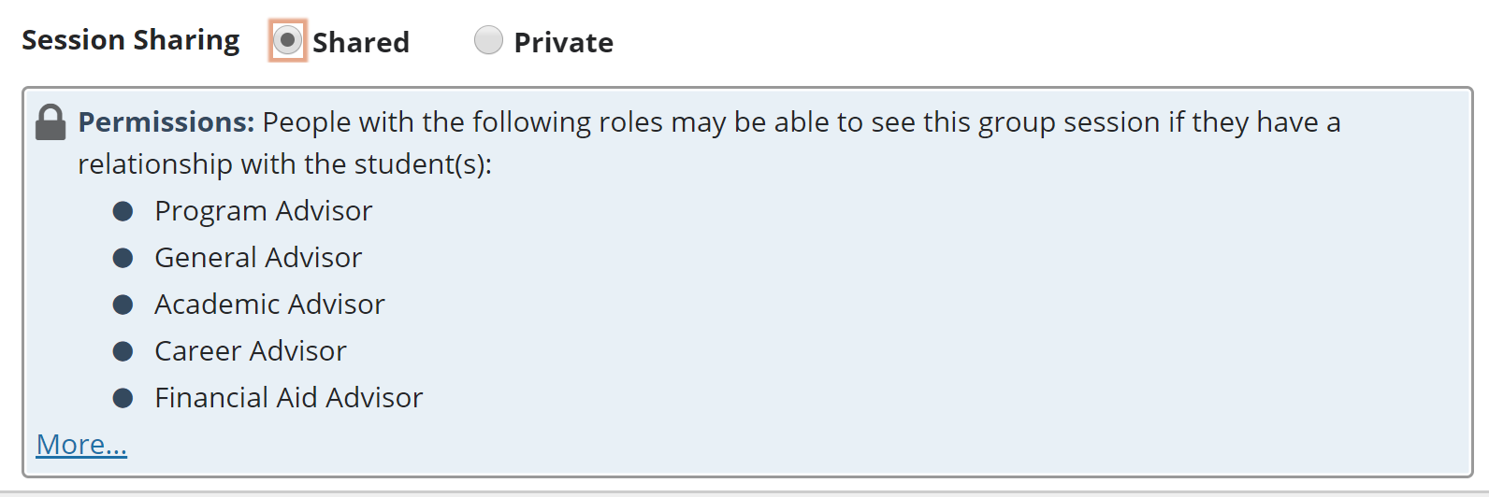

Alternately, you can mark sessions to be Private prohibiting others from viewing this session except for you and your calendar manager(s).

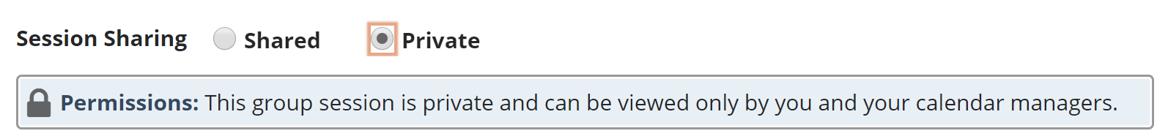

Reserve time on your calendar
Use the Reserve Time option to show time on your calendar as unavailable for appointments during that time.

- Select Reserve Time on your Home page.

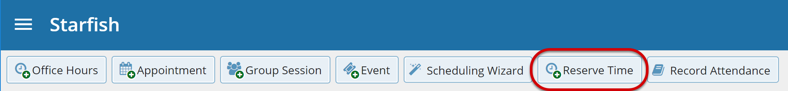

- Fill out the Reserve Time form to include a description of the reserved block, the date and time of occurrence. If the block recurs each week, use the Repeat Weekly Until checkbox to indicate a weekly recurrence, and select the end date for the block using the date picker.

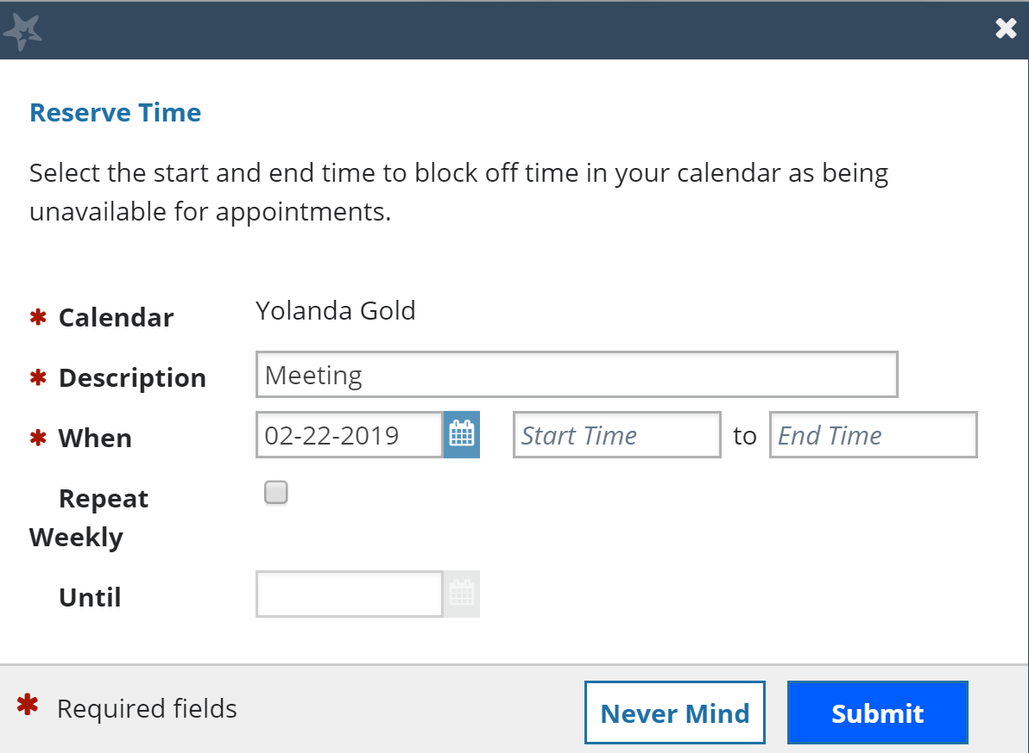

- When you are finished, select Submit.

Event
The Event feature is a way to document attendees after an event occurred. The Event feature cannot be set up for future events, and it is not a way for students to register. It is merely a way to document attendees within Starfish to keep for records, track trends, or send targeted communication. This feature is standard for new clients but can be added for existing clients by contacting Starfish Support or your Starfish Consultant.

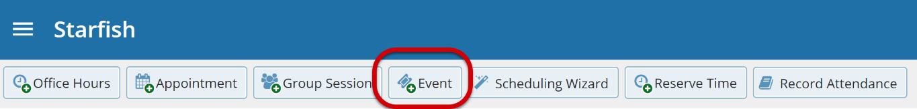

- Select Event from your Home page. The Create Event form displays the Details tab.

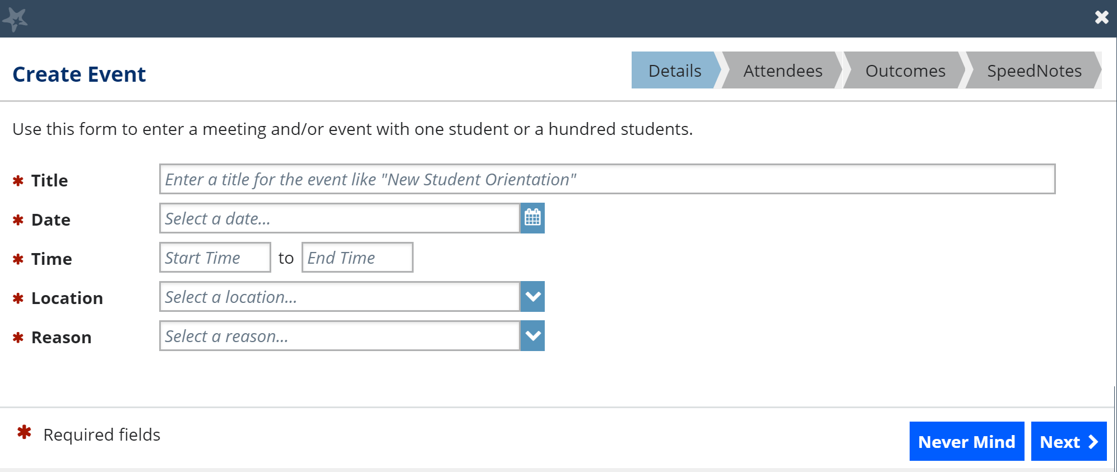

- Fill out the Event form to include a pertinent information regarding the event.

Keep in mind, only events in the past can be added, the calendar will not allow you to pick a date in the future.

- Select Next. The Attendees tab displays.

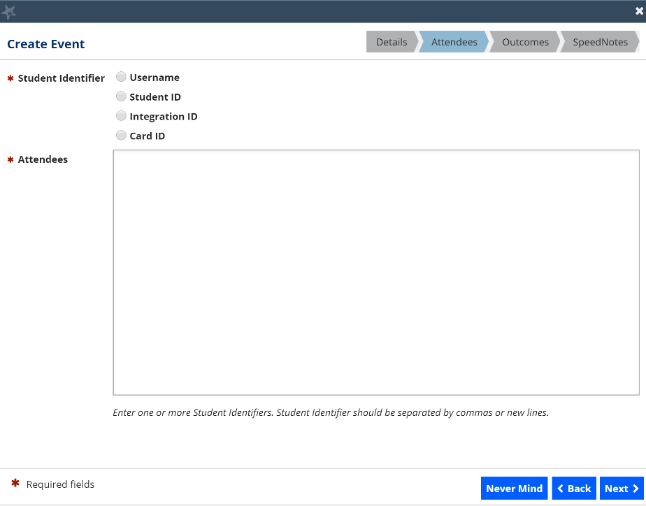

- Select the appropriate Student Identifier from the available options.

- If you received a list from an external source, verify the student identifier used to create the list.

- If you created your list by downloading a list of students from your My Students tab within the Students area, use either the Username or Student ID, both of which are included as column in the download .csv file.

- If you created your list by downloading a list of students from your Tracking tab within the Students area, use the Student ID which is included in the .csv download in the column labeled studentExtId.

- In the Attendees text box, either type or copy and paste a list of attendees (based on the student identifier you selected) into the text box.

- Select Next. The Outcomes tab displays.

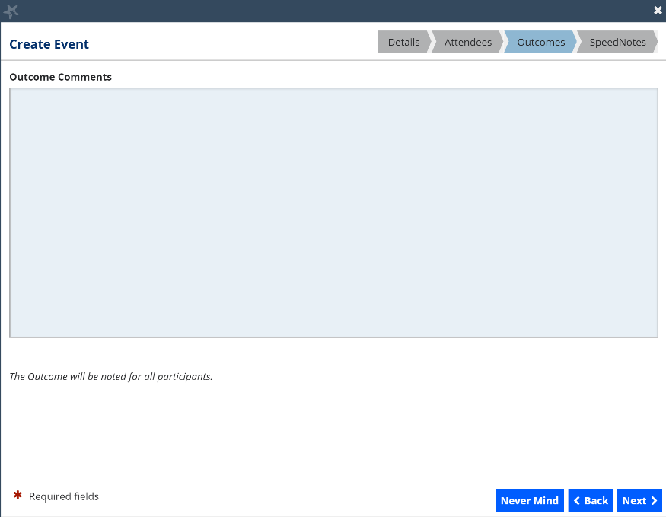
- In the Outcome Comments free text field, enter any applicable comments. The comments you’ve entered will be available on the Student Folder Meetings tab of each attendee entered in the Attendees tab.

- Select Next. The SpeedNotes tab displays.

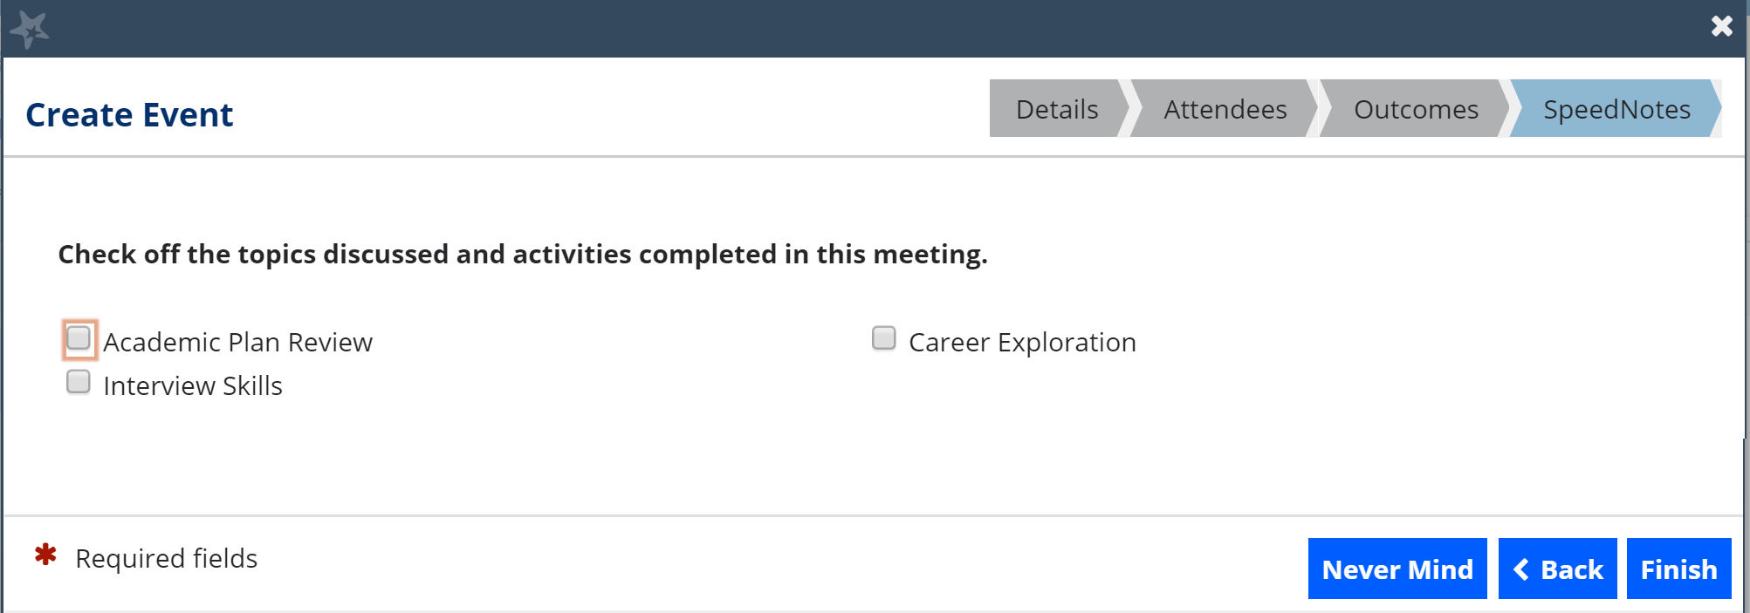

- Select the appropriate checkbox(es) pertinent to the event.

- Select Finish. A confirmation window displays.

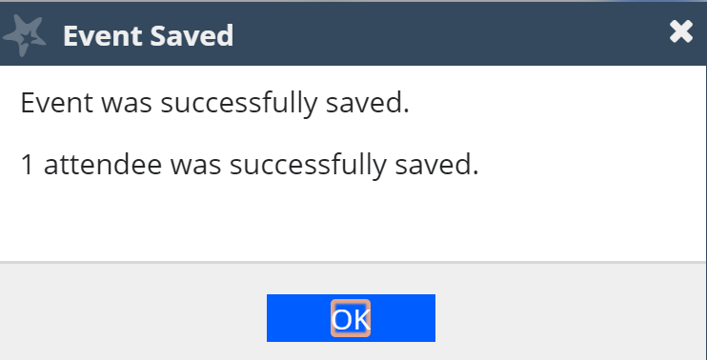
To use the Event feature, your Starfish Administrator must associate your Appointment Type with the permission to add events.

Manage Saved Events
Saved events will be available to view or edit from your Agenda on the Appointments page. Any Outcomes or SpeedNotes for the event will display on the student folder for each attendee that was successfully updated with the event.
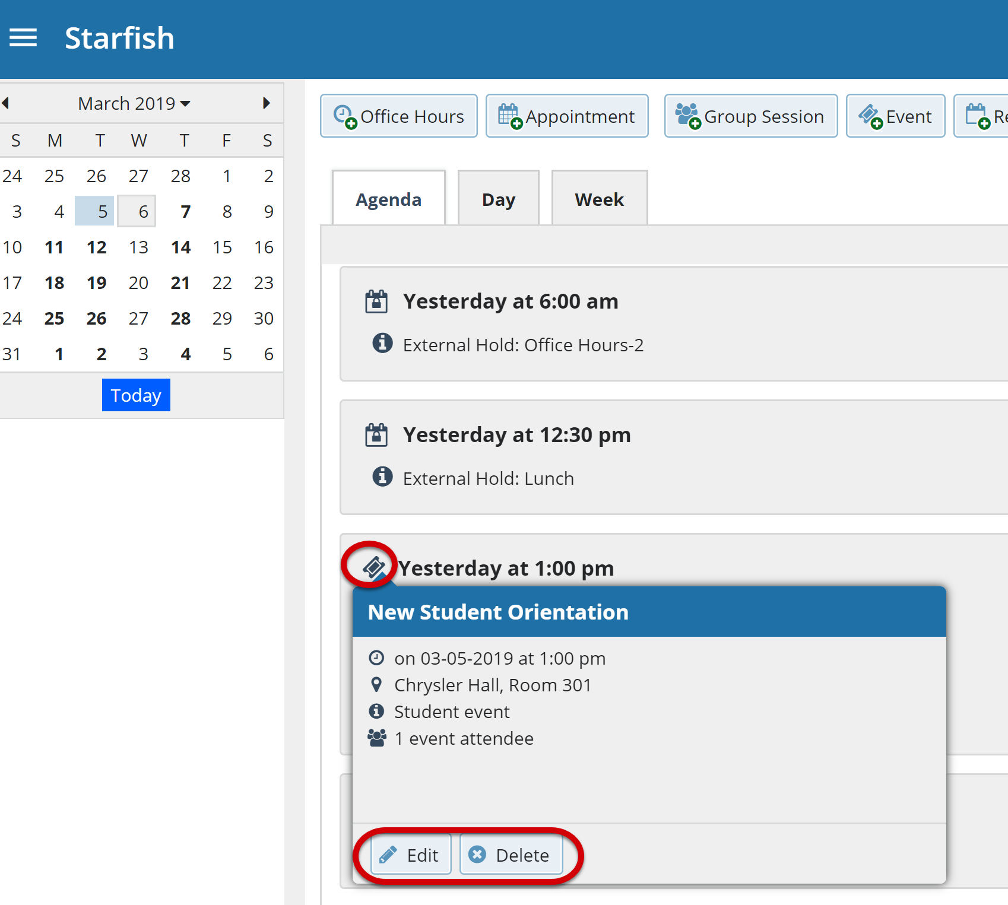

Tips for Creating and Managing Appointments
Students may only schedule appointments with you during times you have designated as available, either through your office hours or group sessions.

You and your designated calendar manager(s) can add appointments wherever you choose with a few exceptions:
  - You cannot overlap a reserved time: If you use the Reserve Time feature to block time on your calendar, you will not be able to add an appointment in the time occupied by the reserved time without first removing the reserved time from your calendar.

  - You cannot overlap a group session: you cannot add an individual appointment that overlaps with a group session previously added to on your calendar.

  - You cannot overlap an external hold: If your Starfish calendar is integrated with an external calendar via Exchange or Google integration, you will find External Holds on your calendar. These represent items that exist on your other calendar (Outlook or Google). You will not be able to add appointments that conflict with external holds on your Starfish calendar.

Notifications
You can set preferences for email sent to you from Starfish for both Appointments and Tracking Items (e.g., flags, to-dos and referrals). (See the Faculty/Staff Getting Started Guide for more on Notifications.)
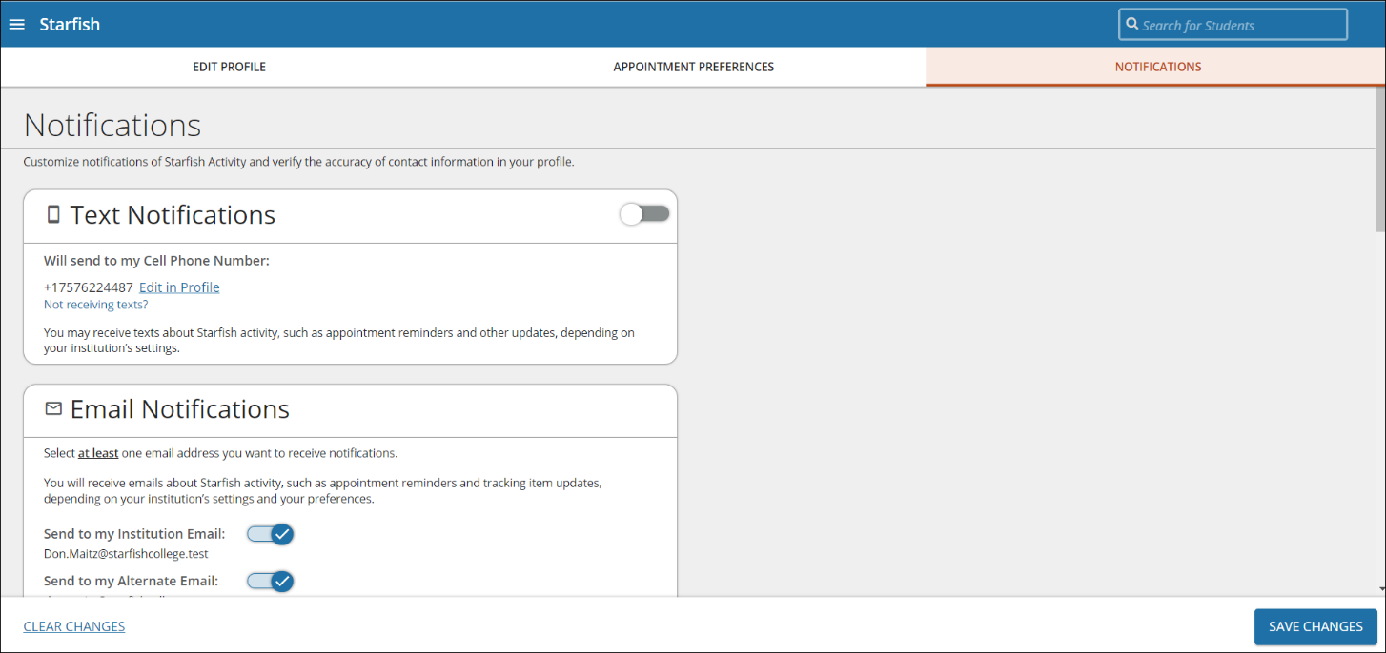

Email Notifications
In the email Notifications section, toggle to turn on at least one email address you want to receive Email Notifications.

Appointment Notifications
Specify when you wish to receive Planning Reminders, Appointment Alerts, and calendar attachments. Institution defaults will be used if you don’t update these options. Each of these is described in the table below:
Don’t send me planning reminders | When this option is selected, you will not receive any email reminders for upcoming appointments.
Send me a notification individually for each appointment | When this option is selected, you will receive a separate email for each appointment at the specified time.
Send me a digest of all appointments | When this option is selected, you will receive one email reminder with all upcoming appointments. The Send Digest at dropdown allows you to specify the cadence of the notifications.

Alert Reminders
Select the Notify me before the start checkbox to receive alerts prior to the appointment (from 15 minutes up to an hour).

Tracking Items

Summary Email
You have the option to receive summary emails of all tracking item and appointment activity by configuring the following options.
Daily: Select this option if you want to receive one email per day at the frequency specified with all relevant activity.
Weekly: Select this option if you want to receive one email per week on the specified day and time. To opt out of email communication, ensure neither option is selected.
None: Select this option if you do not want to receive a summary email.

Tracking Item Updates
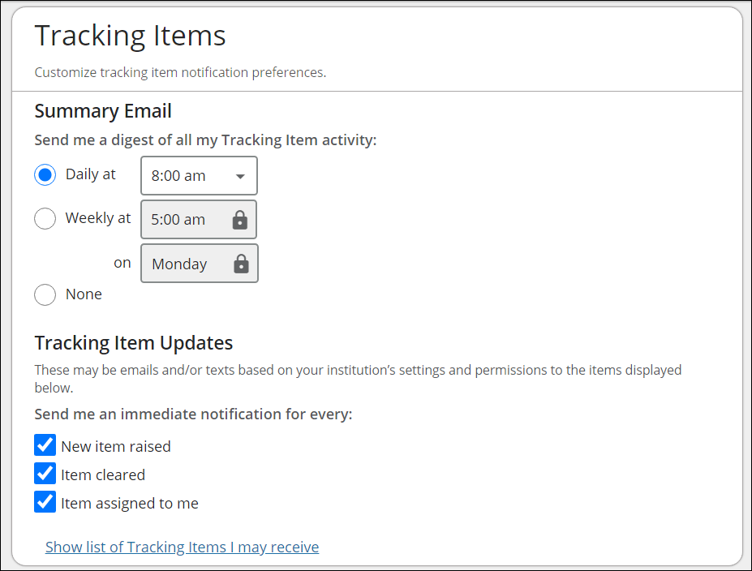
Your Starfish administrator has determined which items you will be emailed. Items that may trigger an email to you are listed in the Flag Rules table below your notification options.

You can customize how you receive those emails including whether you will receive your notifications as a summary email of all recent activity or as individual email for each item. Note, items marked with the Emergency Notification icon will be sent when raised regardless of your settings.

Save Email Notification Preferences
When you have made all necessary edits, select Save Changes.

Calendar Managers
The Calendar Managers section allows you to designate other users who can see and edit your Starfish calendar. Calendar Managers can edit your office hours, appointments, group sessions, events (if turned on) and reserve time on your calendar.
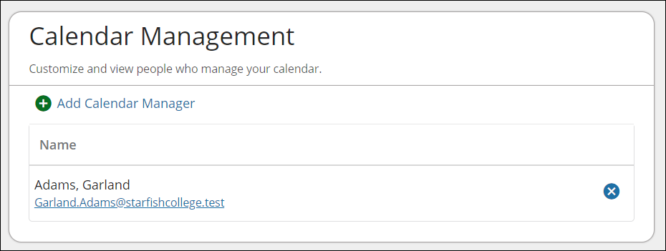

Add Calendar Managers
- From the Appointment Preferences page, scroll to the Calendar Management section.
- Select Add Calendar Manager.
- Select the dropdown to Search for a User to Add.
- Select Add Calendar Manager to finish.

Remove Calendar Managers
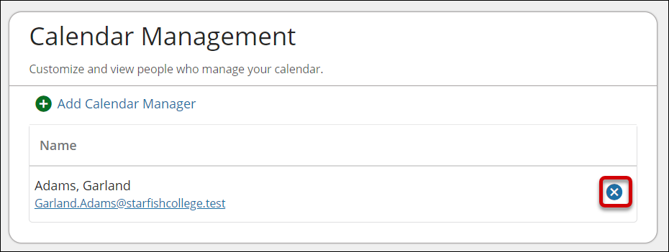
You can remove a Calendar Manager by select the Delete () icon.
If you are unable to remove a calendar manager from this area, contact your Starfish Administrator.

Save Appointment Preferences
When you have made all necessary edits to your profile settings, select Save Changes.

How Calendar Managers interact with your Starfish Calendar
Calendar Managers can view, add, and edit appointments on your Starfish calendar. You can designate other users to be your calendar manager through Appointment Preferences in your profile.

Institutions can create calendar managers via SIS import or administrator upload. You must contact your Starfish administrator to remove calendar managers created via these methods.

Calendar viewing options
If you are a designated calendar manager, a list of calendars you have permission to manage display under the Calendars I Manage heading.
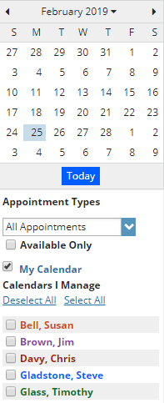
You can filter the calendars displayed by Appointment Type and/or by individual users’ calendars:
  - Use the Appointment Types dropdown to filter the results by appointment type.
  - Select the appropriate checkbox(es) associated with each calendar you’d like to view.

To make it easier to distinguish among calendars, each name is displayed in its own color.
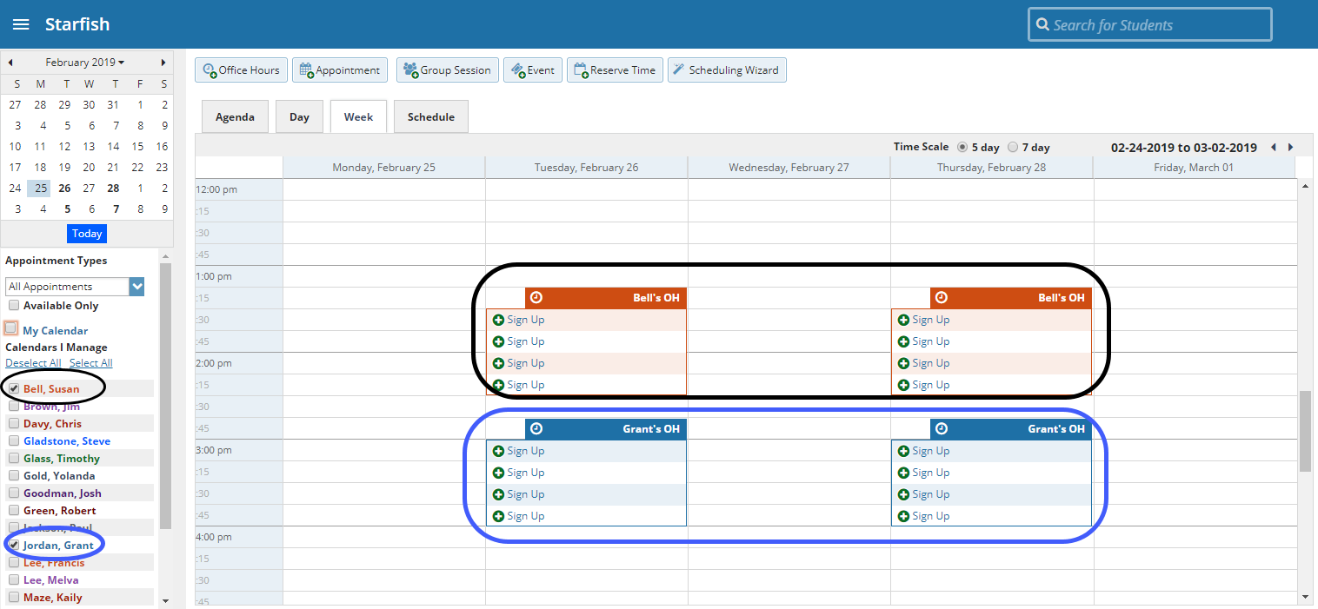

As a calendar manager, a Schedule tab will display along with the Agenda, Day, and Week tabs. If you are opening more than 3 calendars at the same time, the Schedule tab is recommended. If you manage many calendars the Select all calendars option will only be available in the schedule view.
When you select the Schedule tab, Starfish may display a quick reference pop up that includes these tips for using the schedule view:

From the Schedule view, use the time scale option at the top of the schedule view to look at the combined schedules in 15-minute, 30-minute or 1-hour increments. Select an individual’s name in the schedule view to jump to view that user’s calendar in the day view.
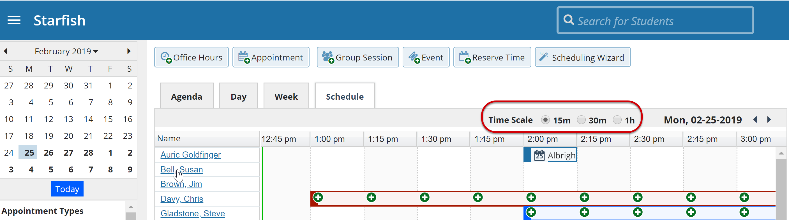

Create and Update Appointments for others
If you are a calendar manager, you will have additional calendar selections when adding an appointment to the calendar.
On the Add Appointment form, you will find a dropdown selector in the Calendar field listing those individuals for whom you have the calendar manager permission.

Select the desired staff member to add an appointment to his/her calendar. Options presented in terms of students, locations and appointment types will be based on the selected user’s role(s).

If you elect to add appointments, office hours, group sessions or reserved time from your Appointments page, individuals who are not checked in the Calendars I Manage section will not be listed as options in the dropdown box for Calendar on the Add forms.
Once the appointment, office hour block, group session or reserve time is created, you cannot modify the person whose calendar it belongs to (i.e. you cannot move it to another person’s calendar by selecting another calendar).

Calendar Sync
In the Calendar Sync section, select the appropriate option to Sync.

Starfish Calendar Sync
Select the appropriate option to sync from your Starfish Calendar to your External Calendar.
Appointment Change | When selected, you will receive calendar attachments for appointment changes from your Starfish Calendar to your External Calendar.
Change to my Office Hours and Group Sessions | When selected, you will receive calendar attachments for changes to your Office Hours and Group Sessions from your Starfish Calendar to your External Calendar.

External Calendar Sync

Outlook Calendar Sync
If your institution has integrated your Outlook with Starfish select the Allow Starfish to read busy times from your Outlook Calendar to prevent scheduling conflicts with two calendars.

Google Calendar Sync
If you would like to sync your Google Calendar with Starfish, select the Click here link for additional instructions. Then select the Allow Starfish to read busy times from your Google Calendar to prevent scheduling conflicts with two calendars.
Enter your Google Calendar link in the Paste Google Calendar Link field to integrate your Starfish Calendar with your Google Calendar. Note, the instructions are provided when you select the Click here link as noted above.
It is highly recommended to keep both calendar attachment options checked (change to my appointments and change to my Office Hours/Group Sessions). This ensures that your external calendar (e.g., Outlook, Google, Entourage) receives the latest information from your Starfish calendar.

External calendar holds on your Starfish calendar
Items from your external calendar display as external holds on your Starfish calendar.
An external hold is distinguishable from a Starfish appointment on your Starfish calendar in two ways:

- The title on the calendar does not include the hyperlink to the student folder.
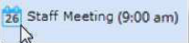  External appt | Starfish appt
- When you hover over the Appointment menu icon the External Hold card is displayed rather than the Starfish Appointment card.
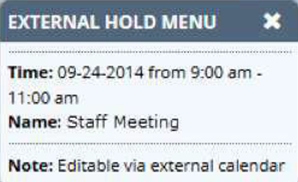
External holds will be respected when a calendar owner or manager is adding an appointment or other reserved time to the calendar. Times will display as unavailable and appointments will not be able to be added over external holds.

External Calendar Integration
Integration with an external calendar allows free/busy information from your external calendar to be displayed on your Starfish calendar. This type of integration is available for Google or Exchange, and your institution must have configured one of those options with Starfish for you to take advantage of it. With Starfish’s adapter installed, Starfish will poll your external calendaring system for shared calendars, and then display the free/busy information from those shared calendars on your Starfish calendar.
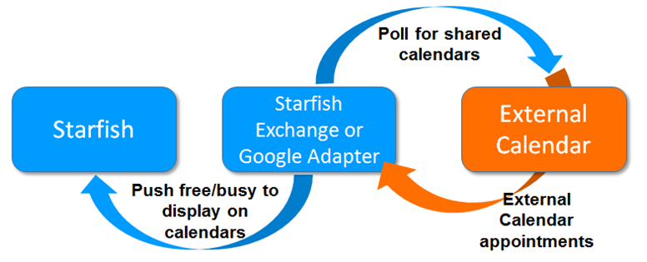

How Starfish Communicates with your Online Calendar
Starfish supports Two-Way Calendar Communication via email with most online calendars (e.g., Microsoft Outlook, Google, Entourage). When an appointment is scheduled or updated in Starfish, a calendar invitation email (with iCal attachment) is sent to the student and the calendar owner allowing users to accept or decline in their email client.

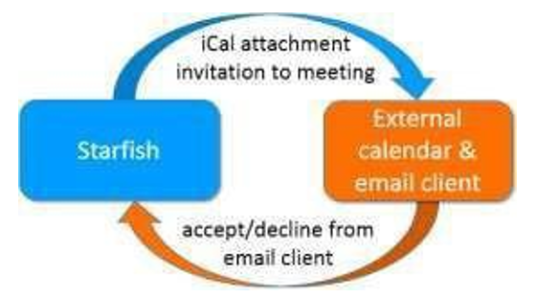
This two-way communication about Starfish appointments is automatically available and requires no additional integration or installation.

When the Starfish Calendar is updated
Starfish triggers an updated calendar invitation (iCal) to be sent to you when a new or updated block of time is available for student meetings.

Notifications
Both you and the student will be sent an iCal when a student appointment is scheduled, changed, or canceled. You can modify whether to receive these notifications in the Appointment Notifications section of your Profile. Starfish highly recommends receiving email notifications for all changes as displayed below.
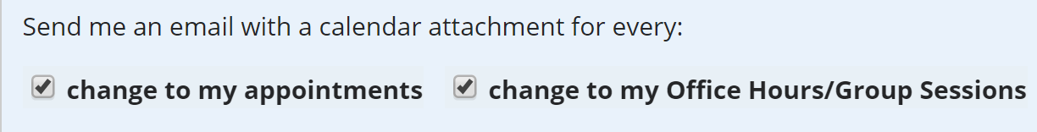

When an invitation is canceled or declined
When you cancel or decline a Starfish invitation from within your external calendar, the cancel/decline is sent to Starfish and is reflected on your Starfish calendar.
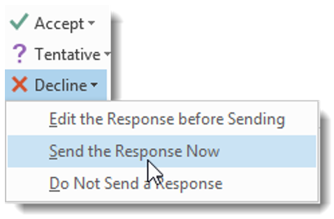
You cannot modify Starfish appointments times in your external calendar. Only Accept, Cancel or Decline are reflected in Starfish. You must select Send the Response Now when declining for Starfish to be notified of the change.

