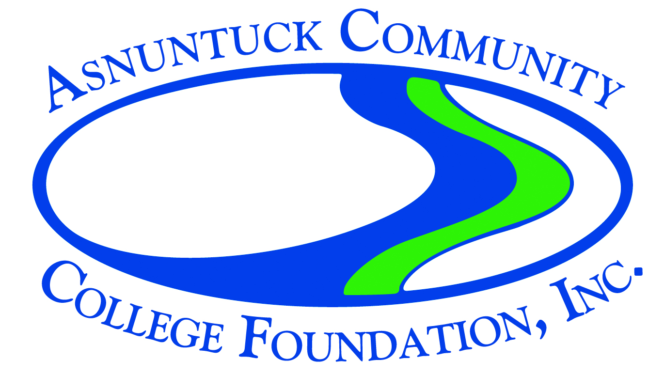
Mini Grant Guidelines
AY 2019-2020

The Asnuntuck Community College Foundation is committed to enhancing the quality of services and programs for students, faculty, and staff. The Foundation works to aid, strengthen, and further the work and service of Asnuntuck Community College. It assists the College in securing financial support for scholarships, mini grants, college events, activities, community, student, and instructor initiatives.
Do you have a special assignment or project you want to incorporate into your class? Do you have an idea for a professional development opportunity? Do you have an innovative project that requires funding? The Asnuntuck Community College Foundation is now accepting mini grant applications. Mini grants are designed to fund projects that benefit students, or a program, curriculum, classroom, or the college as a whole. Mini grants of up to $1,000 are available for projects on a one-time-only basis, based on approved Board funding and availability. Projects may be submitted by an individual staff, faculty member or by small groups. We especially encourage projects involving multiple faculty and staff or those which are joint efforts with community members.
Grant applications are reviewed and considered by a selection committee. When submitting an application, please:
- explain the project thoroughly,
- include specific details about its educational value, and projected numbers served
- show how the project enhances school curriculum,
- attach a clear and concise budget,
- explain funding from other sources if available or supplementing the activity proposed, and
- provide outcomes of the project.
All mini grant proposals will be reviewed. Mini grant proposals that should otherwise be funded through general operating funds of the college will not be funded.
Please document any other current pending source(s) approached or utilized for funding of the project. The Foundation will reimburse individuals for mini-grant related expenditures for which original receipts are provided as detailed in the budget. Items purchased with Foundation grant funds are the property of Asnuntuck Community College, not the department or the individual.
Please complete the attached application following all guidelines. Include a copy of the proposed budget. Proposals, including application and budget, must not exceed three pages. Limit one application per project. Applications submitted based on retroactivity (date/time) of the project will not be considered. Applicants will be notified via email to the contact person listed on the application of a decision within 1 month of receipt of the application. Upon receipt of detailed invoices, applicants will normally receive funds within 30 days.
After completing the application, please email it to Carol LaLiberte at claliberte@asnuntuck.edu and put mini grant application in the subject line.
There are 5 funding periods during which mini grant proposals can be submitted and will be reviewed. The deadlines for mini grant submissions are as follows for fall and spring semesters:
Deadline:
September 30 - notification by October 31
October 31 - notification by November 30
November 30 - notification by December 31
December 31 -notification by January 31
February 28 -notification by March 31
Mini grant applications received after the deadline will be reviewed during the following funding cycle. Funds are limited. The later applicants apply in the fiscal year, the greater chance that funds may not be available.

Updated 7/2019

