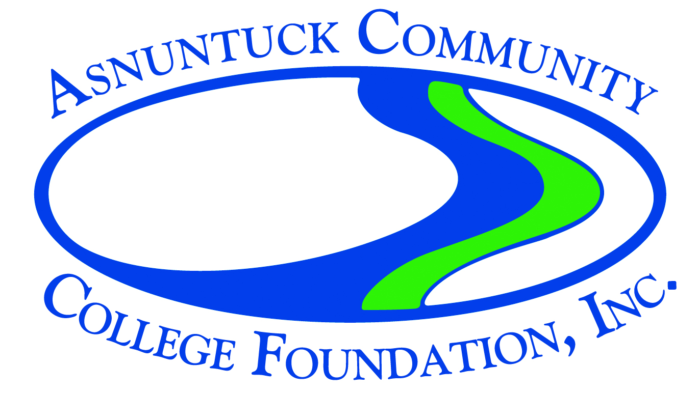

Mini Grant Application
Please check the appropriate submission period for which funds are being requested:
___ September 1-September 30 ___ October 1-October 31
___ November 1-November 30 ___ December 1-December 31
___ February 1-February 28
Funding decisions will be made and applicants notified 2 weeks from the close of the submission period.

Name: |  | Date:
Title:

Phone Number(s):

Contact Name (if not the same as applicant):

Email Address:

Students, Staff, or faculty involved in planning this mini grant:

What date are the funds needed by? ________________________
Approximate date(s) and/or time span of project:

Total Cost of the Project: ___________ Mini Grant Amount Requested: __________
Attach up to two pages including project description and budget.

Project Description: Describe the faculty/staff/students involved in your project, the benefits of the project to our school, or the greater community, and the outcomes for the participants and specifically our students. Provide sufficient information to enable the Mini Grant Committee to have a clear understanding of your project. Include the projected numbers of students to be impacted by this mini grant project and how you arrived at this number.

Budget: Include a complete amount you are requesting from the Foundation and what funds will be spent on.
*Please note that a Mini Grant Outcome Report and Final Expenses Report is due to the Foundation within 30 days after the end of the project.

After completing the application, please email it to Carol LaLiberte at claliberte@asnuntuck.edu Please put “mini grant application” in the subject line.

Updated 7/2019

