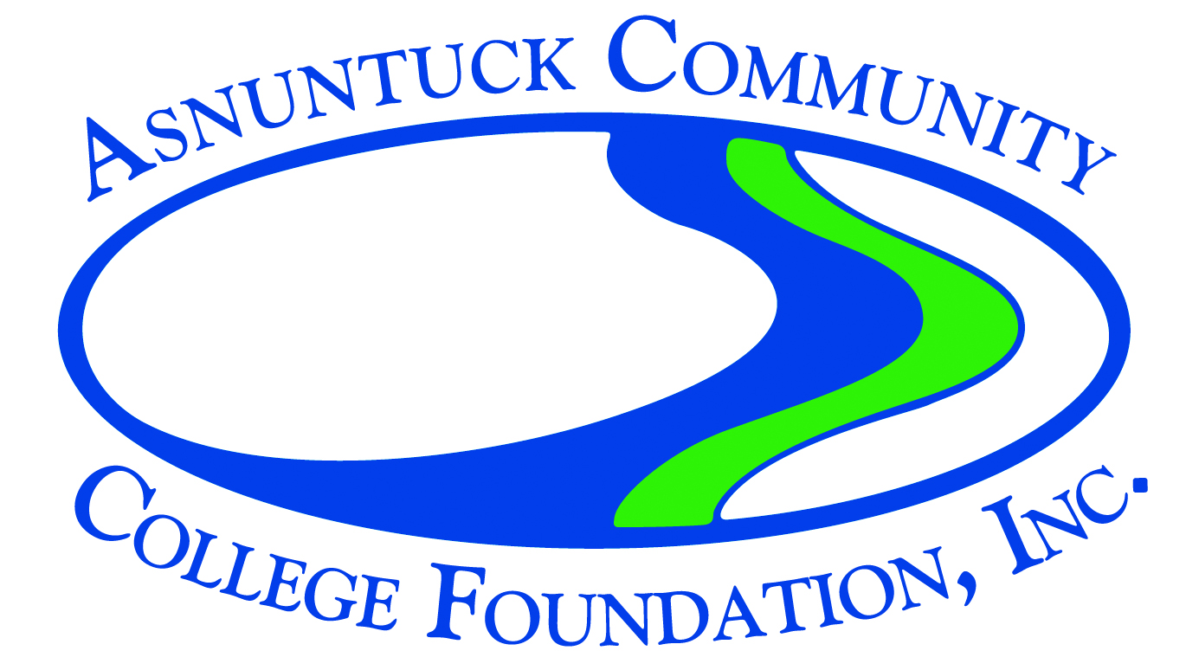
Mini Grant Guidelines

The Asnuntuck Community College Foundation is committed to enhancing the quality of services and programs for students, faculty, and staff. The Foundation works to aid, strengthen, and further the work and service of Asnuntuck Community College. It assists the College in securing financial support for scholarships, mini grants, college events, community initiatives, and student and instructor initiatives.
Do you have a special assignment or project you want to incorporate into your class? Do you have an idea for a professional development opportunity? Do you have an innovative project that requires funding? The Asnuntuck Community College Foundation is now accepting mini grant applications. Mini grants are designed to fund projects that benefit your students, program, curriculum, classroom, or the college in general. Mini grants of up to $1,000 are available for projects on a one-time-only basis, based on approved Board funding and availability. Projects may be submitted by an individual staff or faculty member or by small groups.
Grant applications are reviewed and considered by a selection committee. When submitting an application, please:
- explain the project thoroughly,
- include specific details about its educational value,
- integration of proposed project with school curriculum,
- attach a clear and concise budget,
- explain funding from other sources if available or supplementing the activity proposed, and
- provide outcomes of the project.
Please document any other current pending source(s) approached or utilized for funding of the project. The Foundation will reimburse individuals for mini-grant related expenditures for which original receipts are provided as detailed in the budget. Items purchased with Foundation grant funds are the property of Asnuntuck Community College, not the department or the individual.
Please complete the attached application following all guidelines. Include a copy of the proposed budget. Proposals, including application and budget, must not exceed three pages. Limit one application per project. Applications submitted based on retroactivity (date/time) of the project will not be considered. Applications will now be reviewed approximately every two months - on the same day as the full Foundation Board meeting. Available funds are granted on a first-come first-served basis.
Applicants will be notified of a decision within 60 days of receipt of the application. If approved, applicants should receive funds within 30 days after notification upon receipt of invoice submissions/details.
After completing the application, please email it to Teresa Foley at tfoley@asnuntuck.edu . Please put “mini grant application” in the subject line.

